Analytics using Python

Learning outcomes

1. You will learn Python , a useful language

2. Use programming for problem solving

Great Lakes Institute of Management

A guide to learn python for analytics

P. V. Subramanian

**A workbook on Analytics using Python**

**P. V. SUBRAMANIAN**

**Visiting faculty – Great Lakes Institute of Management**

*Copyright @ 2019 Great Lakes Institute of Management : All contents in this book, including (but not limited to) its contents are proprietary to Great Lakes Institute of Management, Chennai. Any effort at re-using, modifying and circulating both through Digital or Physical means, without the express written permission of the author, will amount to infringement of copyrights, and will be liable for suitable action.*

**Chapter 10. Time Series**

**Univariate time series**

**Table of Contents**

1. INTRODUCTION 6

1.1 WHAT IS TIME SERIES? 6

1.2 TYPES OF DATA 7

1.3 ISSUES WITH DATA 8

1.4 WHY TIME SERIES? 9

1.5 GOALS OF TIME SERIES 9

1.6 ANALYSIS VS FORECASTING 10

1.7 FORECAST GOALS – DESCRPTIVE VS PREDICTIVE GOALS 10

1.8 HOURLY, DAILY, WEEKLY, MONTHLY AND ANNUAL TIME SERIES 11

1.9 TIME SERIES NOMENCLATURE 11

1.10 UNIVARIATE VS MULTIVARIATE TIME SERIES 12

1.11 REGRESSION VS TIME SERIES 12

1.12 TIME SERIES FORECASTING PERFORMANCE MEASURES 13

2. TIME SERIES VISUALIZATION 14

2.1 Line plots 14

2.2 Histogram and density plots 18

2.2.1. Histogram 18

2.2.2. Density plot 19

2.3 Box and Whisker plots 20

2.4 Lag Scatter Plots 22

2.5 Autocorrelation plots 25

3. TEMPORAL DATA FRAMEWORK 26

3.1 WHITE NOISE 26

3.1.1. What is White Noise and why it is important? 26

3.1.2. Time series is not a white noise, when 26

3.1.3. Tools used to check for white noise 27

3.2 RANDOM WALK 30

3.2.1. Detect whether the time series problem is predictable or not 30

3.2.2. RANDOM WALK AND STATIONARITY 33

3.2.3. How do you confirm whether the time series is stationary? 33

3.2.4. How do you MAKE the time series stationary? 34

3.2.5. Random walk predictability 36

3.2.6. Ways to check if the time series is a random walk? 37

3.3 COMPONENTS OF TIME SERIES 38

3.3.1. Decompose Time Series 38

3.3.2. Classical decomposition 38

3.3.3. An additive decomposition 41

3.3.4. Multiplicative Model 42

3.4 SYSTEMIC COMPONENTS VS IRREGULAR COMPONENTS 44

3.5 DETERMINISTIC TRENDS VS STOCHASTIC TRENDS 46

3.6 HOW TO DE-TREND? 46

3.7 SEASONALITY AND HOW TO DE-SEASONALIZE? 50

3.8 CYCLICAL COMPONENTS 58

3.9 IRREGULAR COMPONENTS 58

3.10 Forecast Range, Accuracy and Various Requirements 59

3.10.1. Forecast Range 59

3.10.2. Forecast Accuracy 59

3.10.3. Forecast Requirements 60

3.11 Anomalies in time series data 66

3.11.1. Missing values in time series data 66

3.11.2. Outliers in Time Series data 71

4. FORECAST METHODS 72

4.1 Naïve Approach 72

4.2 Regression on Time 75

4.3 REGRESSION ON TIME WITH SEASONAL COMPONENTS 78

4.4 Simple Average 82

4.5 Moving Average 84

4.6 Error, Trend and Seasonality (ETS) models 87

4.6.1. Exponential Smoothing methods 88

4.6.2. SES - ETS(A, N, N) - Simple smoothing with additive errors 88

4.6.3. Holt - ETS(A, A, N) - Holt's linear method with additive errors 93

*4.7* Holt’s Winter Seasonal Trend 97

4.7.1. Holt WINTER - ETS(A, A, A) - with additive errors 98

4.7.2. HOLT WINTER - ETS(A, M, M) - WITH MULTIPLICATIVE MODEL 101

4.8 AUTO-REGRESSIVE MODELS 103

4.8.1. ARIMA model 106

4.8.2. SARIMA model 110

# INTRODUCTION



## WHAT IS TIME SERIES?

* + A time series is a collection of observations of well-defined data items obtained at equally spaced intervals.
  + For example, retail sales data, yearly sugar cane yield data, stock prices, etc. This is because these data are well defined, consistently measured at equally spaced intervals.
  + Data collected irregularly or once are not time series.

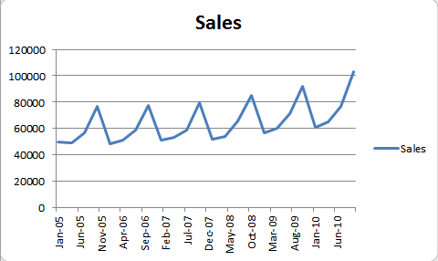

## TYPES OF DATA

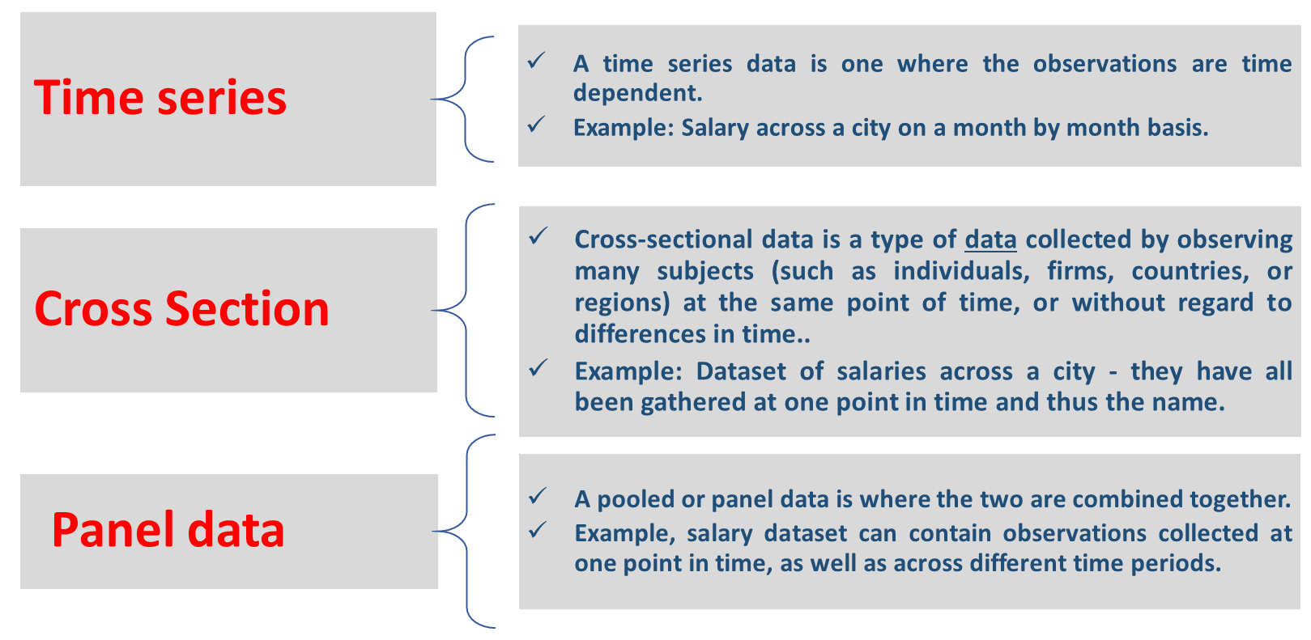

* + *Panel data are multi-dimensional data involving measurements over time. Panel data contain observations of multiple phenomena obtained over multiple time periods for the same firms or individuals.*
  + *Time series and cross-sectional data can be thought of as special cases of panel data that are in one dimension only (one panel member or individual for the former, one time point for the latter).*

**Reference:**

[***https://www.quora.com/What-is-the-difference-between-cross-section-data-time-series-data-and-pooled-data***](https://www.quora.com/What-is-the-difference-between-cross-section-data-time-series-data-and-pooled-data)

*https://en.wikipedia.org/wiki/Panel_data*

## ISSUES WITH DATA

|  |  |  |
| --- | --- | --- |
| **Issues with** | | |
| **Cross section data** | **Time series data** | **Panel data** |
| *The most common issues when working with cross-sectional data are multi-collinearity and heteroscedasticity.* | *With time series data, serial correlation (aka autocorrelation) is an issue.* | *Common issue with panel data is that one may find insufficient observations across a particular time period or cross section in order to generate meaningful results.* |
| * *Autocorrelation occurs when correlations exist across the error term across different time periods.* * *Multicollinearity is where two or more independent variables are correlated with each other.* * *Heteroscedasticity is where the variance of the error term is not constant.* * *It is necessary to properly account for fixed vs random effects (i.e. individual specific effects that are correlated with the independent variables versus those that are uncorrelated.* | | |

## WHY TIME SERIES?

* + *How things change with time is highly common form of data analysis. In business intelligence. this is very important. For example, are revenue from sales increasing or decreasing over time?*

*A time series is important in business and policy planning:*

*1. It studies the past behaviour of the phenomenon.*

*2. It compares the current trends with that in the past or the expected trends.*

*3. It is used in forecasting sales, profit etc. and policy planning by various organizations.*

*4. The cyclic variation helps us understand the business cycles.*

*5. The seasonal variation is very useful for businesses and retailers as they earn more in certain seasons.*

## GOALS OF TIME SERIES

* + *There are two main goals of time series analysis:*

*(a) identify the nature of the phenomenon represented by the sequence of observations, and*

*(b) forecast (predicting future values of the time series variable).*

* + *Both of these goals require that the pattern of observed time series data is identified and mathematically described.*
  + *Once the pattern is established, we can interpret and integrate it with other data (i.e., use it in our theory of the investigated phenomenon, e.g., seasonal commodity prices).*
  + *We can extrapolate the identified pattern to predict future events.*

## ANALYSIS VS FORECASTING

* + *Time series analysis involves developing mathematical models that best describe an observed time series in order to understand the underlying causes. This answers Why questions, by making assumptions about the form of the data and decomposing the time series into its constituent elements.*
  + *Time series forecasting involves taking models fit on historical data and using them to predict future observations, which is unavailable. We use past data to predict future.*
  + *The forecasting model performance is evaluated by testing how well the model has predicted with respect to the actual observations.*
  + *MAPE (Mean Absolute Percentage Error / Mean Absolute Percentage Deviation), is one of the measures of prediction accuracy of a forecasting method.*

## FORECAST GOALS – DESCRPTIVE VS PREDICTIVE GOALS

***Descriptive Goals***

1. *Model to determine its components in terms of seasonal patterns, trends, relation to external factors, and the like.*
2. *Used for decision making and policy formulation.*
3. *Identify and quantify demand during different seasons for inventory planning*

***Predictive goal***

1. *To forecast future values*
2. *Forecast future demand*

## HOURLY, DAILY, WEEKLY, MONTHLY AND ANNUAL TIME SERIES

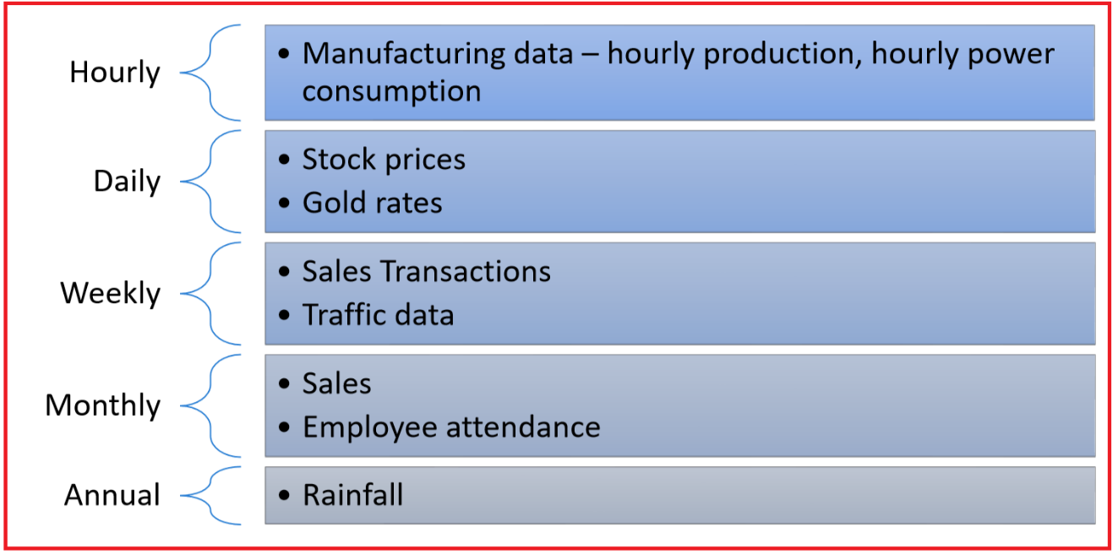

## TIME SERIES NOMENCLATURE

* + *The current time is denoted as t and previous time (lags) is t-1, time prior to previous time is t - 2 and immediate future time (next time) is t + 1. Lag of 5 indicates t - 5.*
  + *A time series is a sequential set of observations, measured at discrete intervals in time and denoted by (y, y1, y2, ..., yN).*
  + *You may think of these observations as a finite sample from a time-series stochastic process that began infinitely far back in time and will continue into indefinite future. ..., y-3, y-2, y-1, y, y1, y2, ..., yN, yN+1, yN+2, ...*
  + *Note that the measurements taken during an event in a time series are arranged in chronological order.*
  + *Each element is treated as a random variable with a probability distribution.*

## UNIVARIATE VS MULTIVARIATE TIME SERIES

* + *A time series containing records of a single variable is termed as univariate. Example: Data of hourly temperature- Temperature is a single time dependent variable.*
  + *A time series containing records of more than one variable is termed as multivariate. Here, each variable depends not only on its past values but also has dependency on other values.*
  + *This dependency is used for forecasting future values like Demand for a product at time, t.*
  + *Examples include: Data containing time, temperature humidity, wind speed. Note the variables like humidity, wind speed impact temperature in addition to time.*

## REGRESSION VS TIME SERIES

* + *A time series is a sequence of data points, measured at regular time intervals over a period of time. Regression analysis is a statistical process for determining the relationship between two or more variables where a change in a dependent variable is associated with a change in one or more independent variables.* Refer:

*https://www.bing.com/search?q=what+is+regression%3F&qs=n&form=QBRE&sp=-1&pq=what+is+regression%3F&sc=8-19&sk=&cvid=F3CEBFA6DA424BD09A01081ACB9388AD#*

* + *Time Series regression model is an extension of the Ordinary regression model with the following conditions:*
  1. *Variables are observed in time*
  2. *Auto correlation between time events exists (Next value in time series is affected by earlier values in the time series).*
  + *The target variable can be influenced by past values of the input variables.*

## TIME SERIES FORECASTING PERFORMANCE MEASURES

* *There are many time series forecasting performance measures to provide a summary of the skill and capability of the forecast model that make predictions.*
* *Time series focus on the prediction of real values, called regression problems.*

1. ***Forecast error*** *is the difference between expected and predicted value.*
2. ***Mean forecast error*** *is the average of the forecast error values.*
3. ***Mean Absolute Error (MAE)*** *is calculated as the average of the forecast error values after ignoring their sign.*

* *MAE = mean(abs(forecast error)) where abs() is the absolute function to force the value to be positive.*
* *We can use the mean_absolute_error() function from scikit-learn library for calculating the mean absolute error for a list of predictions. A mean absolute error of zero indicates no error.*

1. ***Mean Squared Error (MSE)*** *is calculated as the average of the squared forecast error values.*

* *This gives more weight for large errors.*
* *We use mean_squared_error() function from scikit-learn to calculate the mean squared error for a list of predictions.*

1. ***Root Mean Squared Error (RMSE)*** *is calculated as the square root of the mean squared error.*

* *RMSE error values are in the same unit of measure as the predictions.*

1. ***Mean Absolute Percentage Error (MAPE)*** *measures the deviation from the actual data in terms of percentage.*

* *Since this measure is a percentage, it can be easier to understand than other measures.*

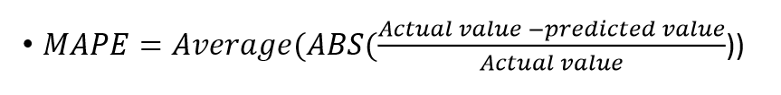



# TIME SERIES VISUALIZATION

* *Plots of raw sample time series data reveals valuable insights to identify time-related structures such as trends, seasonality influencing the choice of the model.*
* *We shall use the minimum daily temperature dataset, which describes the minimum daily temperatures over a period of 10 years 1981 - 1990 in the city of Melbourne, Australia to show various plots.*



## Line plots

* *In this plot, time is shown on the x-axis with observed values of data (temperature) along the y-axis.*
* *Airlines Passenger dataset describes the total number of airline passengers over time. The units are a count of the number of airline passengers in thousands. There are 144 monthly observations from 1949 to 1960. Draw a line plot.*

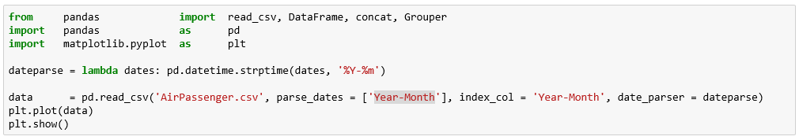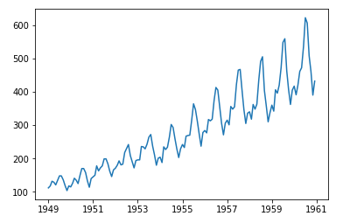

* *We shall use the minimum daily temperature dataset to draw a line plot.*

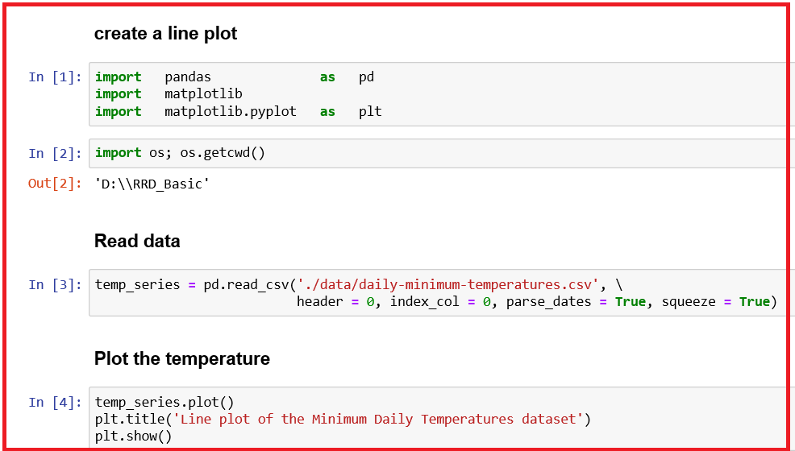

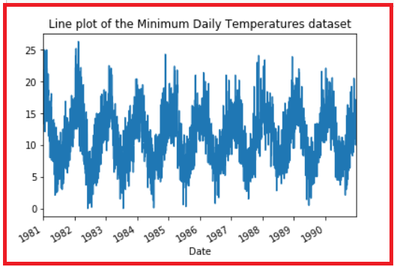

* *The line plot is quote dense.*
* *Since the data set spans 10 years, we can group data by year and create a line plot for each year for direct comparison.*

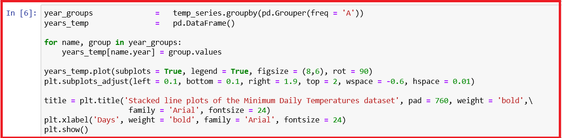

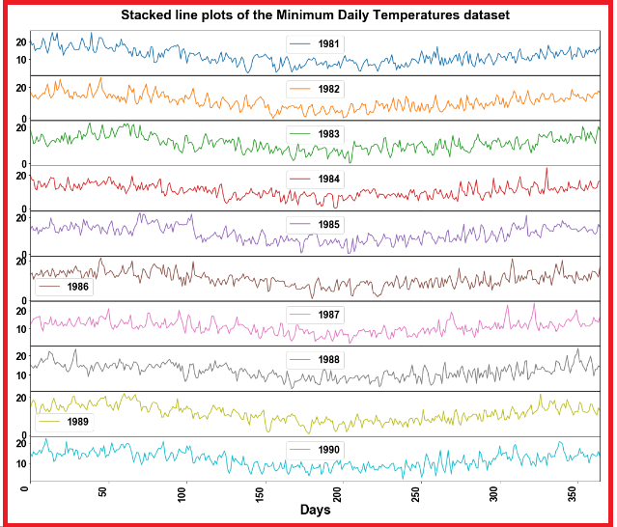

* *We have created ten-line plots, one for each year from 1981 to 1990, where each line plot is 365 days in length.*

## Histogram and density plots



### Histogram

* *A histogram groups values into bins, and the frequency of observations in each bin provides insight into the underlying distribution of the observations.*

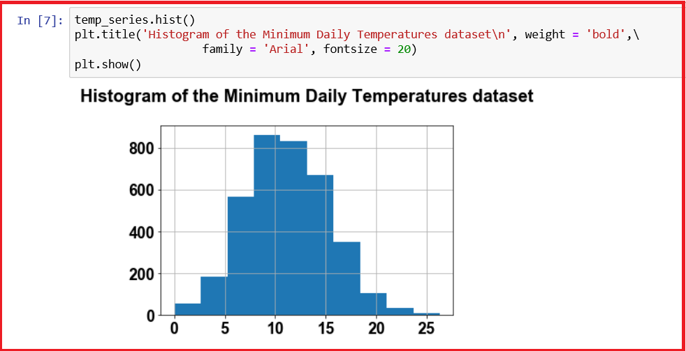

* *The above plot shows a distribution that looks strongly Gaussian. The function, hist() automatically selects the size of the bins based on the spread of values in the data.*

### Density plot

* *Density plot gives us the better idea of the shape of the distribution of observations.*
* *In this plot, a function is used to fit the distribution of observations and a smooth line is used to summarize this distribution.*

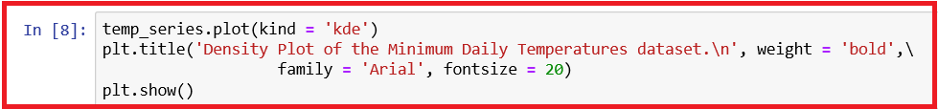

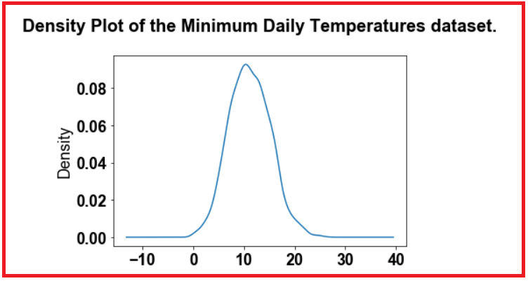

* *We observe that the above density plot, reveals a little asymmetrical distribution and the need to explore statistical hypothesis tests to formally check is the distribution is Gaussian and to use data transformation to make the distribution Gaussian.*

## Box and Whisker plots

* *Box and Whisker plot draws a box around the 25th and 75th percentile of the data that captures the middle 50% of observations. A line is drawn at the 50th percentile (median) and whiskers are drawn above and below the box to summarize the general extent of the observations. Dots are drawn for outliers outside the whiskers or extents of the data.*
* *We shall use the Minimum Daily Temperature data set grouped by years.*
* *We create box and whisker plot for each year and lined up side-by-side for direct comparison.*

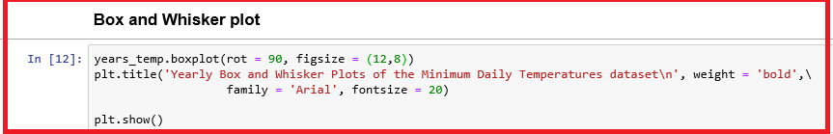

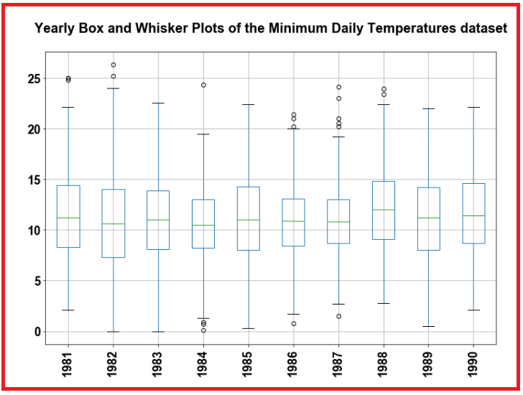

* *We observe that there is NO big variation across years in temperatures.*
* *We can check the distribution of values across months within a year say 1990.*

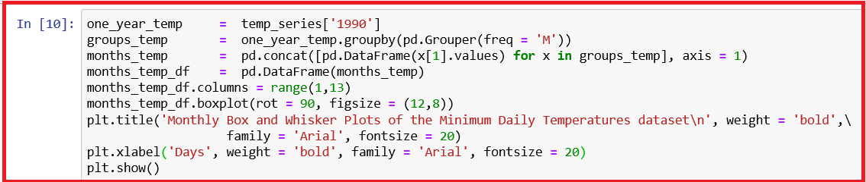

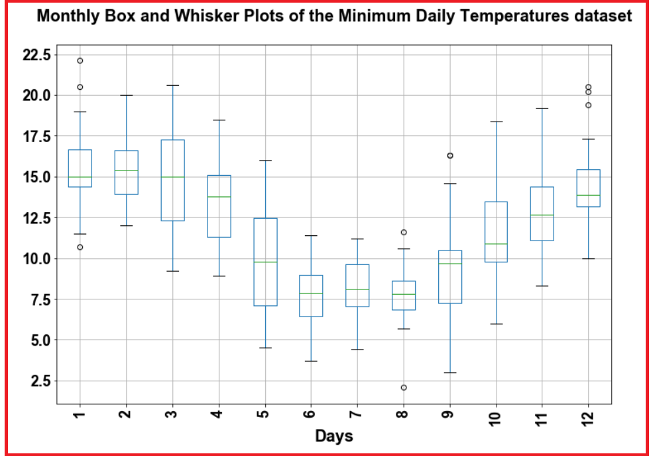

* *We observe that the 12 box and whisker plots show the significant change in distribution of minimum temperatures across the months of the year, 1990 from summer* in January to winter* in the middle of the year and back to summer again.*

*\* Note*

* *Southern Hemisphere, contains all or parts of five continents (Antarctica, Australia, about 90% of South America, one third of Africa and several islands off the continental mainland of Asia) and most of the Pacific Islands in Oceania. Owing to the tilt of Earth's rotation relative to the Sun and the ecliptic plane, in southern hemisphere, summer is from December to March and winter is from June to September.*

*Ref:* [*https://en.wikipedia.org/wiki/Southern_Hemisphere*](https://en.wikipedia.org/wiki/Southern_Hemisphere)

## Lag Scatter Plots

* *The lag_plot() in pandas explores the relationship between each observation and a lag of that observation.*

*Note: Previous time step in a time series is called lag 1, the observations at two-time steps ago lag = 2, etc.*

* *The function plots the observation at time t on the x-axis and the observation at the next time step (t+1) on the y-axis.*
* *If the points cluster along a diagonal line from the bottom-left to the top-right of the plot, it suggests a positive correlation relationship.*
* *If the points cluster along a diagonal line from the top-left to the bottom-right, it suggests a negative correlation relationship.*
* *Either relationship is good as they can be modelled.*
* *More points tighter in to the diagonal line suggests a stronger relationship and more spread from the line suggests a weaker relationship.*

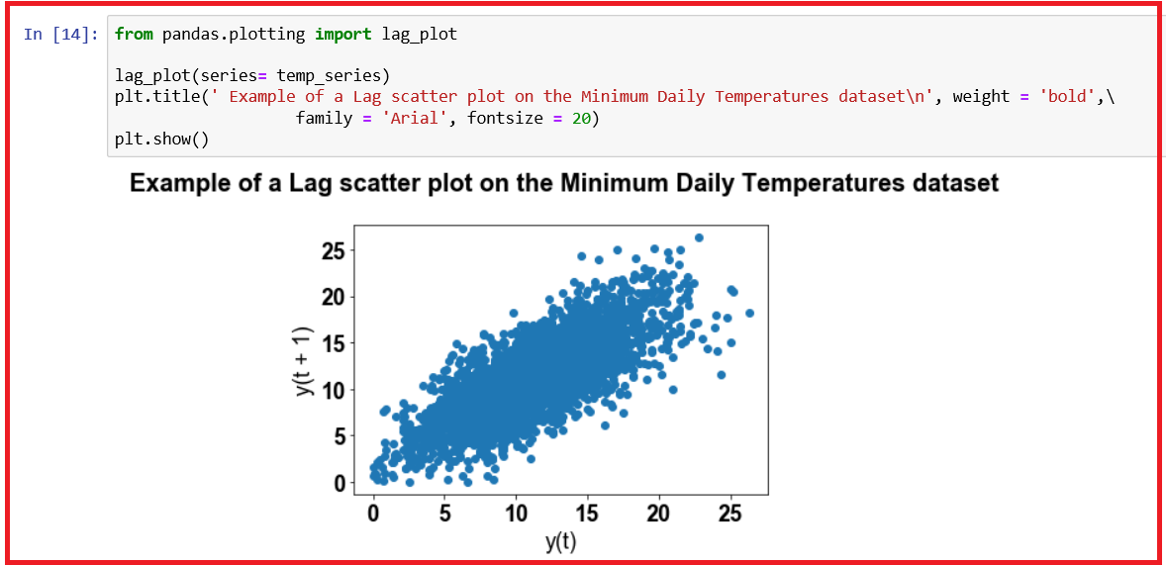

* *The lag plot reveals a strong positive correlation between observations and their lag 1 values.*
* *We can create a scatter plot for the observation with each value in the previous week (seven days). We create a subplot that plots each observation with a different lag value.*

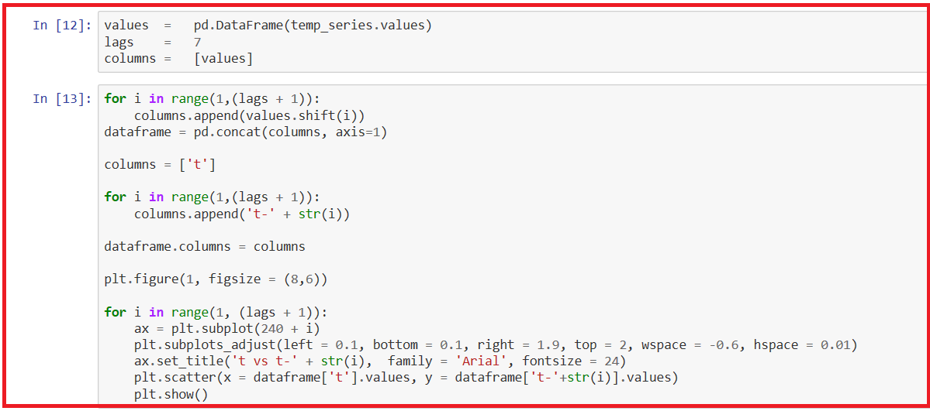

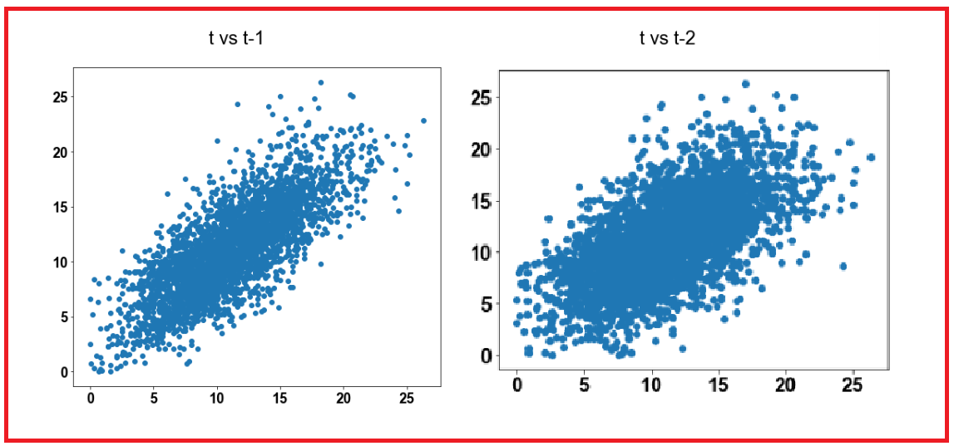

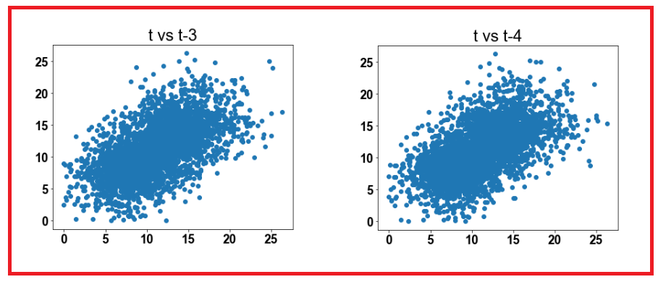

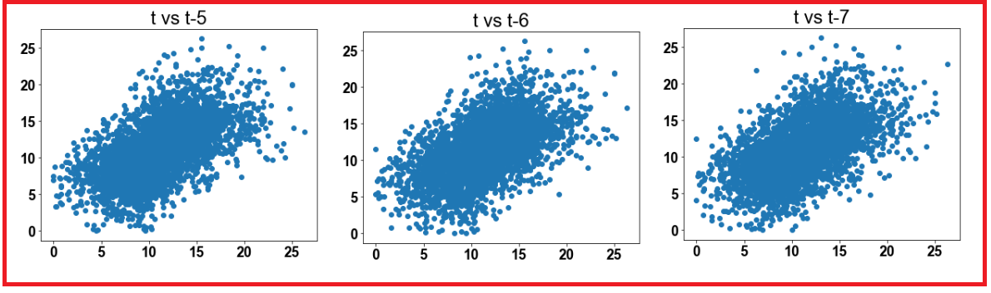

* The above lag plots suggest very strong positive relationship between the observation with each of value in the last week.

## Autocorrelation plots

* The function, autocorrelation_plot() in Pandas creates a plot between observations and their lags.

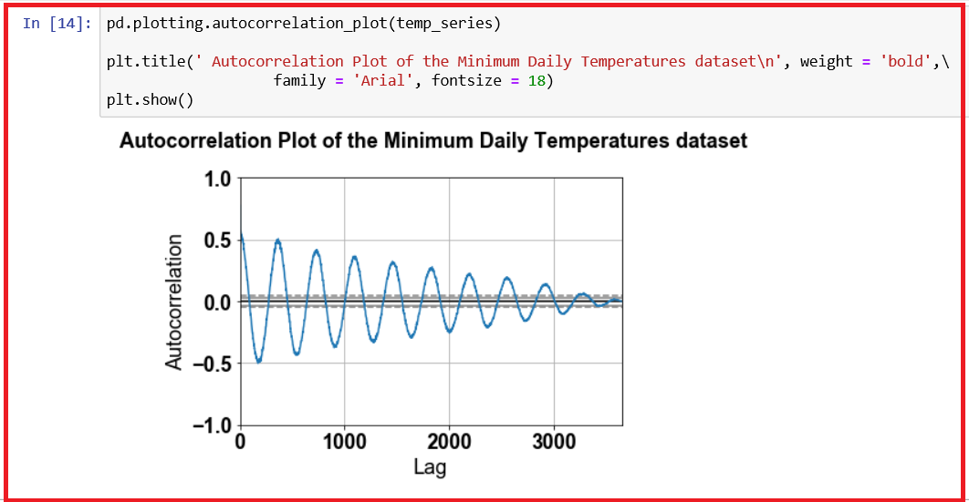

* From the above plot, we observe cycles of strong negative and positive correlation. This captures the relationship of an observation with past observations in the same and opposite seasons or times of year. Sine waves like those displayed here are a strong sign of seasonality in the dataset.
* The autocorrelation function (ACF) at lag k, denoted by pk, of a stationary stochastic process is defined as
* ρk = ϒk / ϒ0 where ϒk = cov(yi, yi+k) for any i. Here, ϒ0 is the variance of the stochastic process.
* The autocovariance function at lag k, for k >= 0, of the time series is defined by sk = (1/n) ∑(yi - ybar) (yi-k - ybar)
* ACF at lag k, ϒk = sk / s0 for k >= 0
* The variance of the time series is s0. A plot of ϒk against k is known as a correlogram.

# TEMPORAL DATA FRAMEWORK



## WHITE NOISE



### What is White Noise and why it is important?

* + *A time series is white noise if the variables are independent and identically distributed with a mean of zero.*
  + *The series of forecast errors should ideally be white noise. When all of the signal information in the time series has been harnessed by the model for making predictions, forecast errors are only white noise and further improvements to the forecast model is not possible.*

### Time series is not a white noise, when

1. *Time series does not have a non-zero mean*
2. *Variance in the time series change over time and not constant*
3. *Values in the time series correlate with lag values.*

### Tools used to check for white noise

1. *Line plot to check for gross features like a changing mean, variance, or obvious relationship between lagged variables*
2. *Summary statistics to check the mean and variance of the whole series*
3. *Autocorrelation plot to check for gross correlation between lagged variables.*

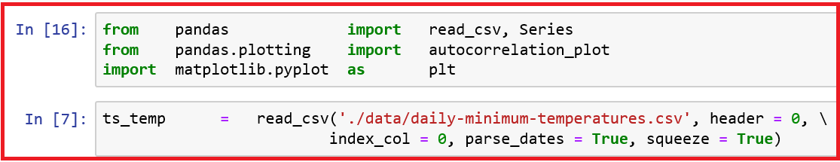

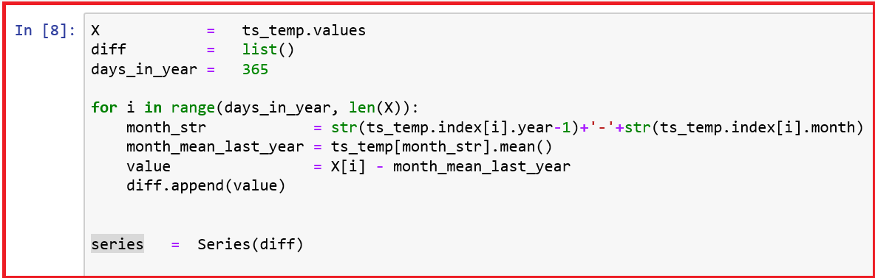

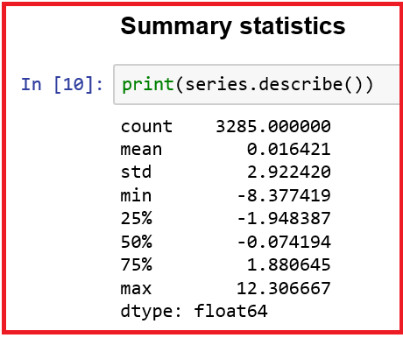

**We observe that the mean is nearly 0.0 and the standard deviation is 2.92.**

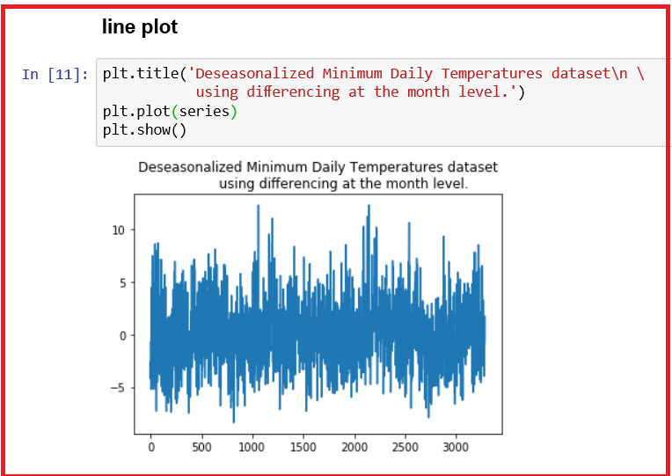

**We observe from the line plot of the series that the series is random.**

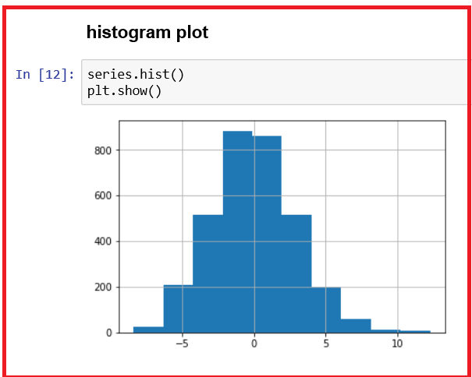

**We observe from the histogram that the distribution is Guassian.**

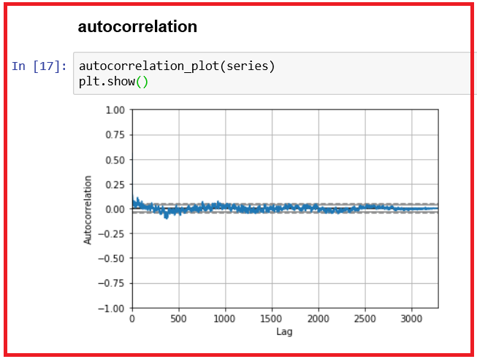

**The correlogram does not show any obvious autocorrelation pattern. There are some spikes above both the 95% and 99% confidence level on both sides of zero line.**

**Inference**

**The differenced series is white noise since,**

* + *We observe that the mean is nearly 0.0 and the standard deviation is small (2.92).*
  + *We observe from the line plot of the series that the series is random.*
  + *We observe from the histogram that the distribution is Gaussian.*

1. *The correlogram does not show any obvious autocorrelation pattern.*

## RANDOM WALK



### Detect whether the time series problem is predictable or not

* + *Random walk helps us to understand the predictability of the time series.*
  + *A random walk is a time series model where the current observation is equal to the previous observation with a random step up or down.*
  + *Mathematically, you can represent time series model xt as xt = xt-1 + wt*
  + *Here xt is the current observation, xt-1 is the previous observation and*

*wt is the discrete white series noise.*

* + *Random walk is different from a list of random numbers, in which the next value in the sequence is not dependent from the previous value.*
  + *In random walk, the process used to generate the series compels dependence from one-time step to the next step. Hence, the name random walk or drunkard's walk.*
  + *Mean of a random walk is zero and the covariance is actually time-dependent being the variance multiplied by the time. Hence, a random walk is non-stationary.*

**Random model working is given below:**

1. Start with -1 or 1, a random number
2. Select randomly -1 or 1 and add it to the observation from the previous time step.
3. Repeat step 2 as required
   * *We create a random walk by building up a list of 1000 time steps.*

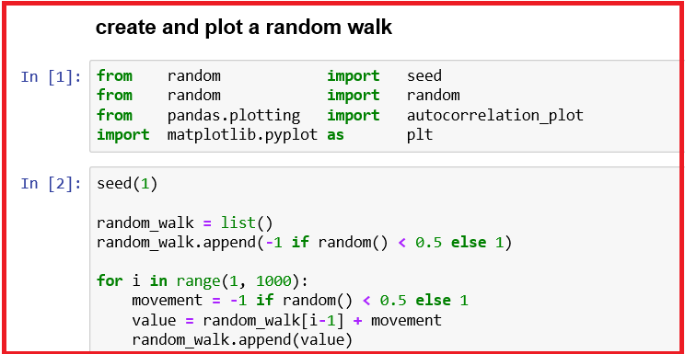

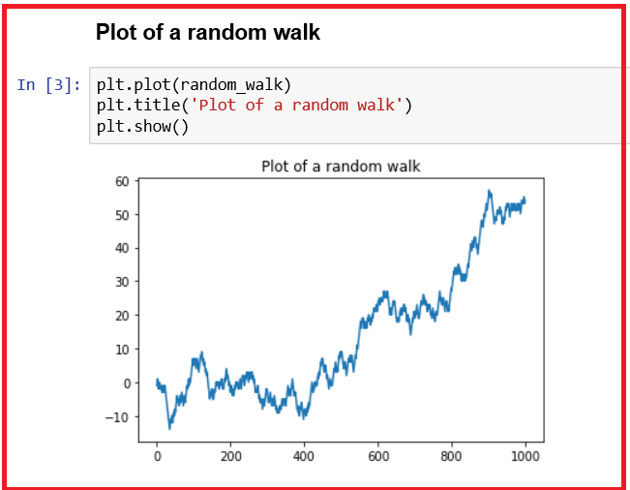

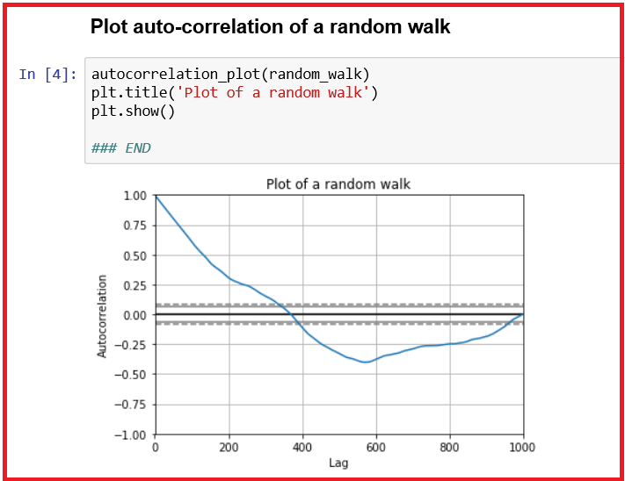

**INFERENCE**

* + *The line plot of the random walk looks like a realistic time series in shape and movement.*
  + *In the auto-correlation plot reveals the expected trend across the first few hundred lag observations.*

### RANDOM WALK AND STATIONARITY

* + *A stationary time series is one where the values are not a function of time.*
  + *We are aware that the observation in a random walk are dependent on time and hence non-stationary.*

### How do you confirm whether the time series is stationary?

* + *Using a statistical significance test, Augmented Dickey-Fuller test, we can confirm this. By using adfuller() function in statsmodels package, we can perform this test.*
  + *The null hypothesis of the Augmented Dickey-Fuller test is that the time series is non-stationary.*

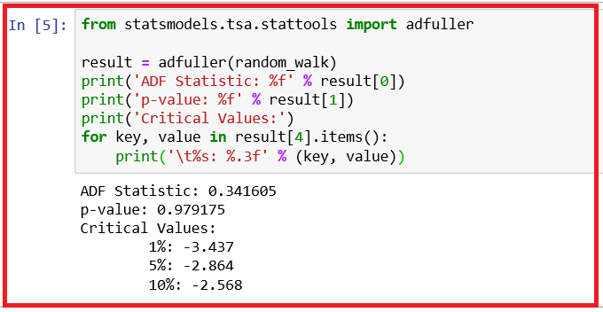

* + *We observe that the*
  1. *p value (0.341605) > 0.05*
  2. *test statistic value was 0.341605 and it is larger than all of the critical values at the 1%, 5%, and 10% conﬁdence levels.*
  + *So, we do not have evidence to reject the null hypothesis and conclude that the time series is non-stationary.*

### How do you MAKE the time series stationary?

* + *Take the first order differences of the observations. We replace each observation with the difference between it and the previous value.*

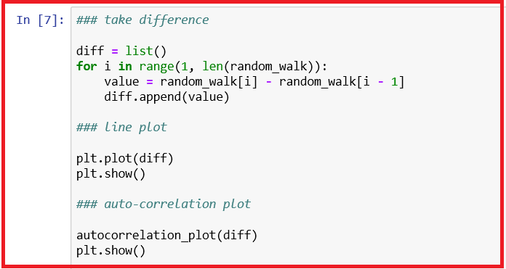

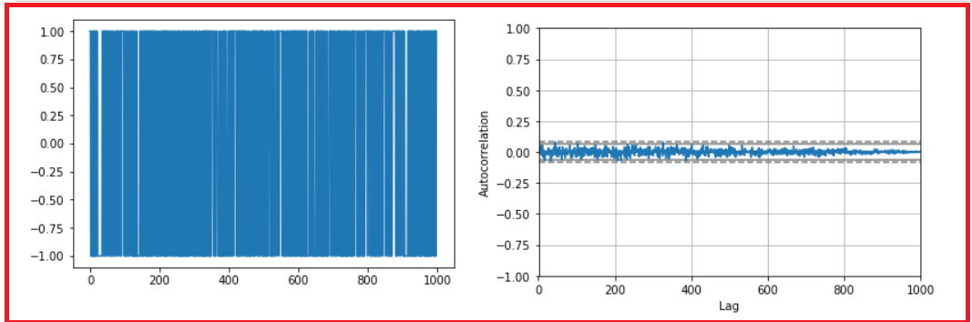

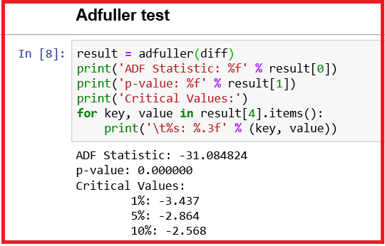

**Inference**

* + *From the difference plot, we don’t have any observation to learn from.*
  + *From the auto-correlation plot, we observe that all correlations are close to zero and they lie below the 95% and 99% confidence levels showing stationarity.*
  + *Augmented Dickey-Fuller test confirms that time series is stationary as the p-value of the test is nearly zero and it is less than 5% level of significance.*

### Random walk predictability

* + *A random walk is not predictable. At best, you can use the previous time step to predict the next time step since next time step is a function of the prior time step.*
  + *This is known as persistent model or naive forecast.*
  + *You can implement this in python by splitting the dataset into train and test tests, then using the naive forecast model you predict the outcome using a rolling forecast method. After predicting the outcome in the test data set, evaluate the model accuracy by using the root mean squared error (RMSE).*

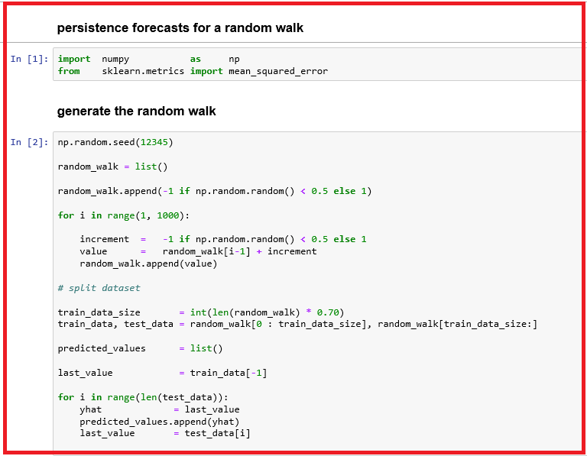

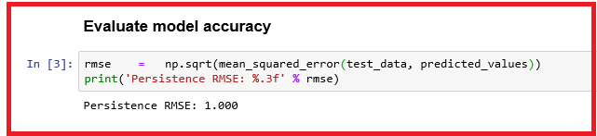

**Inference**

* + *We observe that Root Mean Squared Error of the model is 1.*
  + *We are aware of the fact that the variation from one-time step to the next is either 1 or -1.*

### Ways to check if the time series is a random walk?

1. *Check if the time series shows a strong time-related dependence that decays linearly*
2. *Check if time series that is non-stationary after changing it to stationary shows no perceptible data structure*
3. *Check if the naive forecast model provides the best source of reliable prediction*
   * *Yes to any of the above questions indicates your time series is random walk.*
   * *Always compare your models with Naive forecast model. If your model does not perform better than the Naive forecast model, it is highly probable that you are working with random walk model.*
   * ***The human mind sees patterns everywhere and we must be vigilant that we are not fooling ourselves and wasting time by developing elaborate models for random walk processes.*** *Refer: Introduction to Time Series Forecasting with Python - Jason Brownlee*

## COMPONENTS OF TIME SERIES



### Decompose Time Series

* + *The decomposition of time series is a statistical task that deconstructs a time series into several components such as level, trend, seasonality, and noise components, each representing an underlying pattern category. We shall study these components in detail later.*
  + *A time series is an aggregate or combination of these four components. All the time series components have a level and noise. The trend and seasonality components are optional.*

### Classical decomposition

* + *The classical decomposition method originated in 1920s. It is the starting point for most other methods if time series decomposition.*
  + *In classical decomposition, it is assumed that the seasonal component is constant from year to year. For multiplicative seasonality, the seasonal period, m values that form the seasonal component are referred to as seasonal indices.*

***Two forms of classical decomposition***

* 1. *An additive decomposition*
  2. *A multiplicative decomposition*
  + *The statsmodels library provides an implementation of the naive, or classical, decomposition method in a function called seasonal_decompose(). You need to specify whether the model is additive or multiplicative.*
  + *The seasonal_decompose() function returns a result object which contains arrays to access four pieces of data from the decomposition.*

<https://machinelearningmastery.com/decompose-time-series-data-trend-seasonality/>



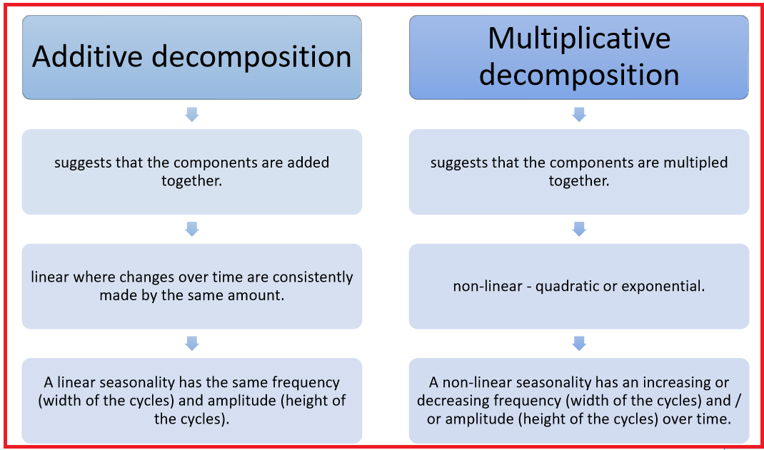

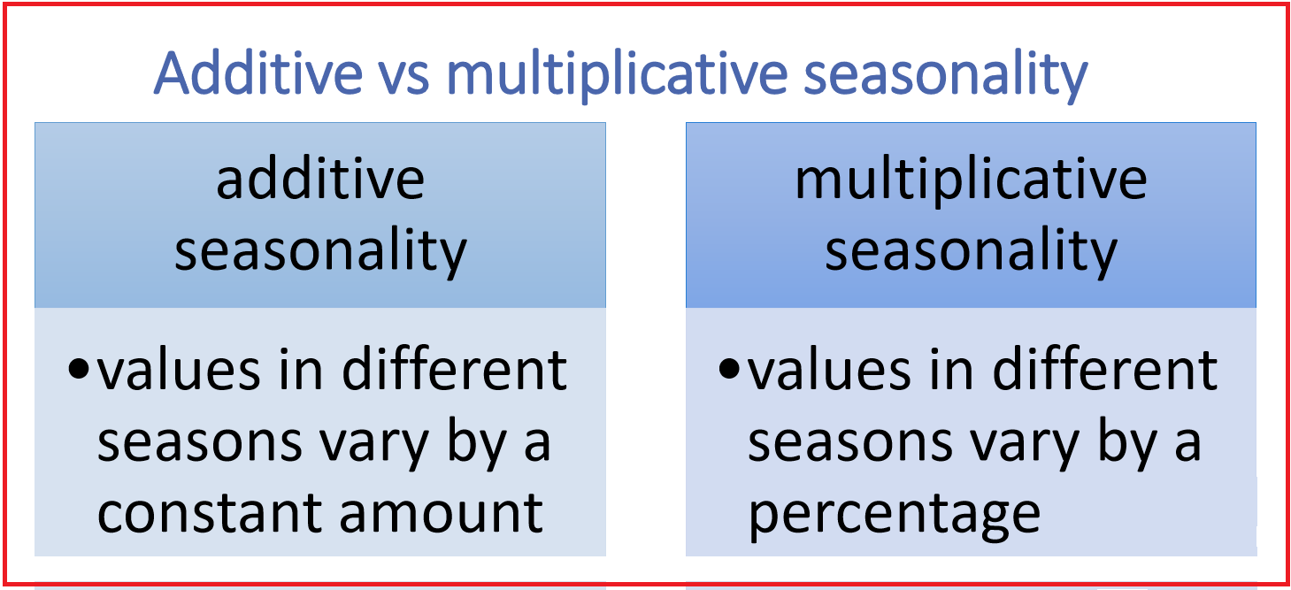

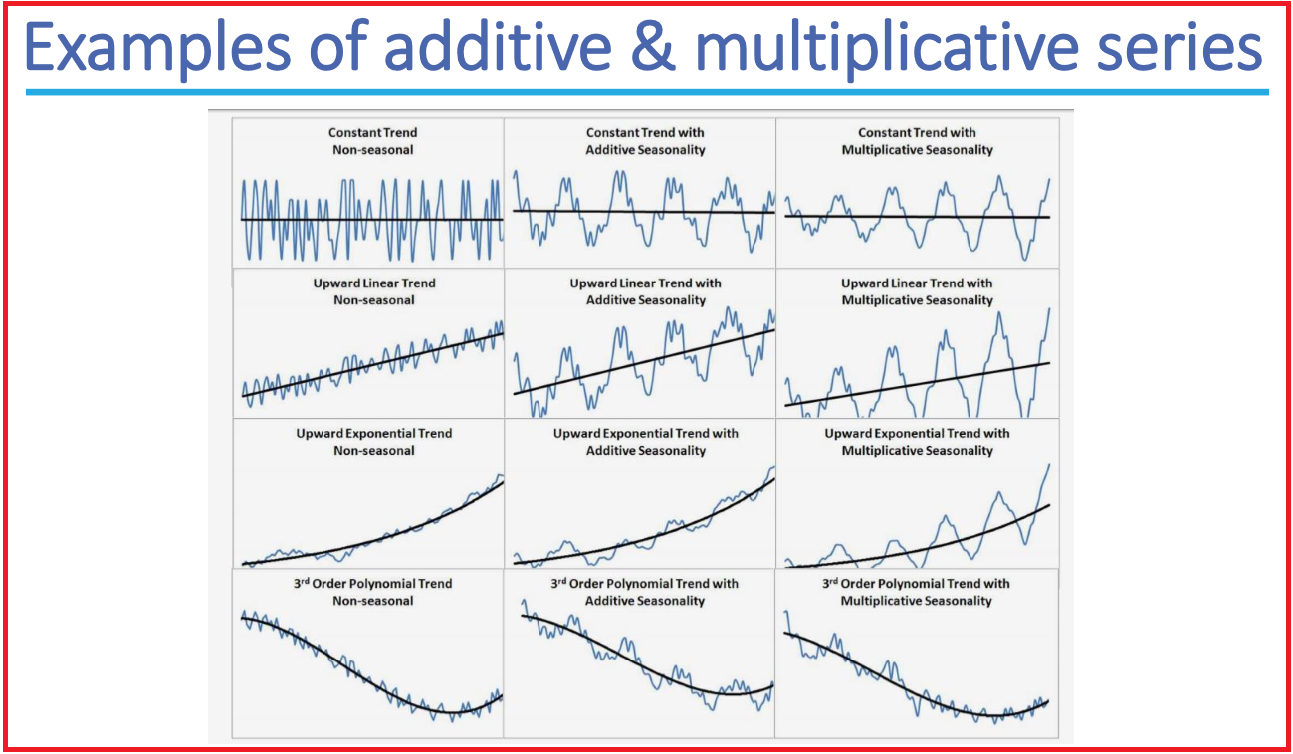



### An additive decomposition

* + *An additive model is linear where changes over time are consistently made by the same amount.*
  + *A linear seasonality has the same frequency (width of the cycles) and amplitude (height of the cycles).*
  + *An additive model suggests that the components are added together as follows:*
  + *y(t) = Level + Trend + Seasonality + Noise*
  + *We shall plot retail turnover.*

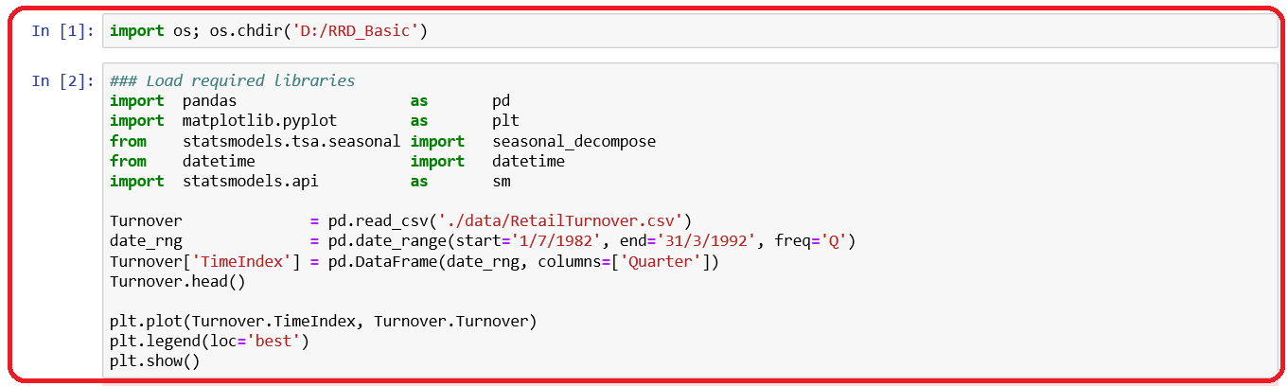

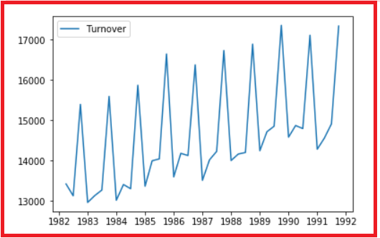

* + *We shall decompose retail turnover data as an additive model. We set the frequency of the observations as 4, representing a quarter.*

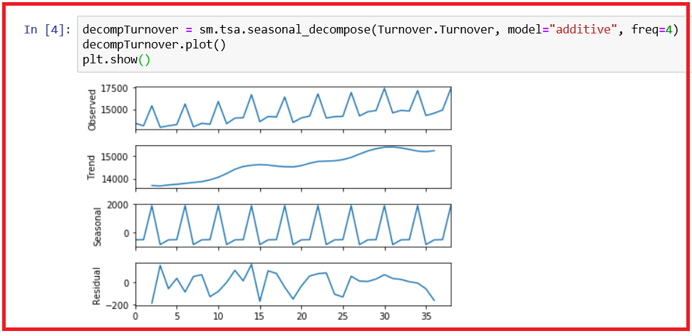

* + *We had performed the decomposition, and plotted the 4-resulting series.*
  + *We observe that the trend and seasonality are clearly separated.*
  + *We can access each of the trend, seasonality and residual component after decomposing.*

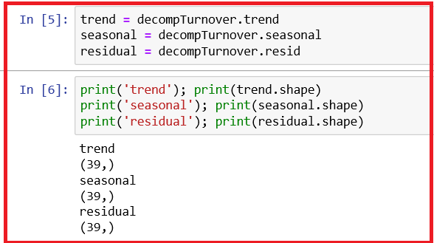

### Multiplicative Model

* + *A multiplicative model suggests that the components are multiplied together as follows:*
  + *y(t) = Level × Trend × Seasonality × Noise*
  + *An additive model is non-linear such as quadratic or exponential.*
  + *A non-linear seasonality has an increasing or decreasing frequency (width of the cycles) and / or amplitude (height of the cycles) over time.*
  + *Perform multiplicative model decomposition on International Air Passengers Data.*
  + *First, we shall plot the data.*

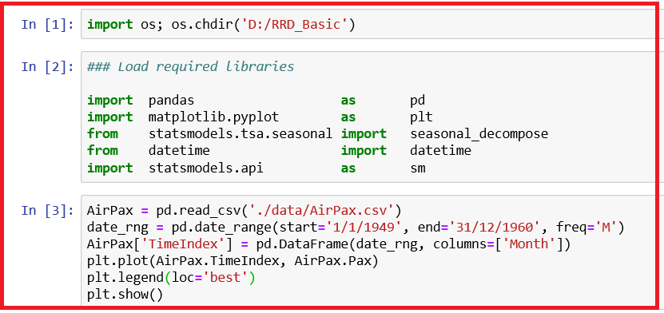

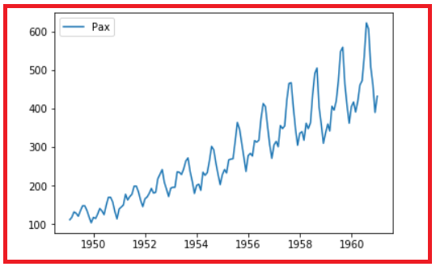

* + *We shall decompose International Air Passengers Data as a multiplicative model. We set the frequency of the observations as 12, representing a month.*

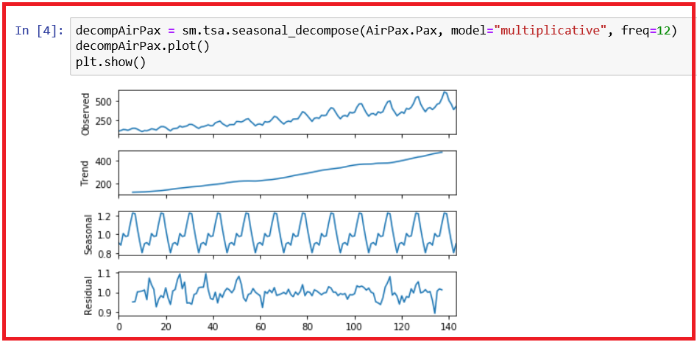

* + *We had performed the decomposition, and plotted the 4-resulting series.*
  + *We observe that the trend and seasonality are clearly separated.*
  + *We can access each of the trend, seasonality and residual component after decomposing.*

## SYSTEMIC COMPONENTS VS IRREGULAR COMPONENTS

* + *All, time series have a level, most have a noise, and the trend and seasonality are optional.*
  + *For many time series, most important features are trends and seasonal variations.*
  + *You may observe that observations close together in time tend to be correlated (serially dependent).*
  + *There are two components of a time series:*

1. *Systemic component contains Trend, Seasonality and Cyclic components. These can be estimated and interpreted. Forecast of time series involves estimation and extrapolation of these components.*
2. *Irregular component contains error or random component that cannot be modelled.*
   * *Forecasting methods attempt to isolate the systematic part and quantify the noise level.*
   * *The systemic part is used for generating point forecasts.*
   * *Level of noise helps assess the uncertainty associated with the point forecasts.*

***Components of Time Series***

* + *The above components combine in some way to provide the observed time series.*
  + *We make assumptions about these components both in behaviour and how they are combined, which allows them to be modelled using traditional statistical methods.*
  + *These components may be the most effective way to make predictions but not always.*
  + *A cyclical pattern exists when data point moves up and down that are not of fixed period. The duration of these fluctuations is more than a year, say two years.*
  + *The duration of a cycle depends on the type of business or industry being analyzed.*
  + *Think of business cycles which usually last several years, but where the length of the current cycle is unknown beforehand.*
  + ***Note: Seasonality is always a fixed and known period. Hence seasonal time series are also known as periodic time series.***

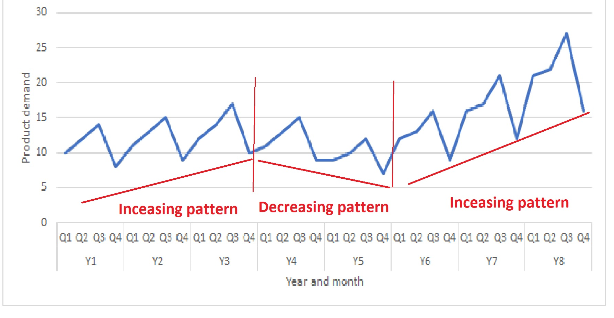

## DETERMINISTIC TRENDS VS STOCHASTIC TRENDS

* + *Deterministic Trends: They consistently increase or decrease and are easier to identify. Time Series with a deterministic trend always revert to trend in the long run. Forecast intervals have constant width.*
  + *Stochastic Trends: They increase and decrease inconsistently. Time series with a stochastic trend never revert to trend since the effects of shocks are permanent. Forecast intervals increase over time.*

## HOW TO DE-TREND?

* + *A deterministic trend is completely predictable and not variable, whereas a stochastic trend is not predictable.*
  + *Series with stochastic trend have to be differenced to make them stationary.*
  + *For series with a deterministic trend, polynomial trend, polynomial de-trending is a correct transformation to achieve stationary.*

***Detrend by differencing***

* + *A new series is constructed where the value at the current time step is calculated as the difference between the original observation and the observation at the previous step.*

*lag(t) = yt - yt-1*

* + *We shall use Shampoo sales data set which describes the monthly number of sales of shampoo over a three-year period. The units are a sales count and there are 36 observations. The original dataset is credited to Makridakis, Wheelwright, and Hyndman (1998).*
  + *Data source: Data Market*
  + *https://datamarket.com/data/set/22r0/sales-of-shampoo-over-a-three-year-period*
  + *View data set*

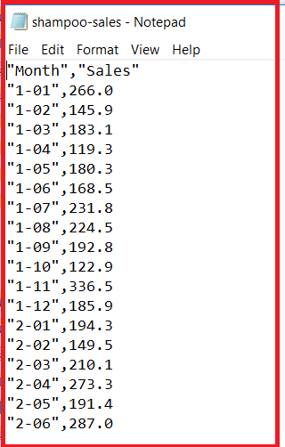

* + *Read Time Series data (Shampoo Sales data) using Python*

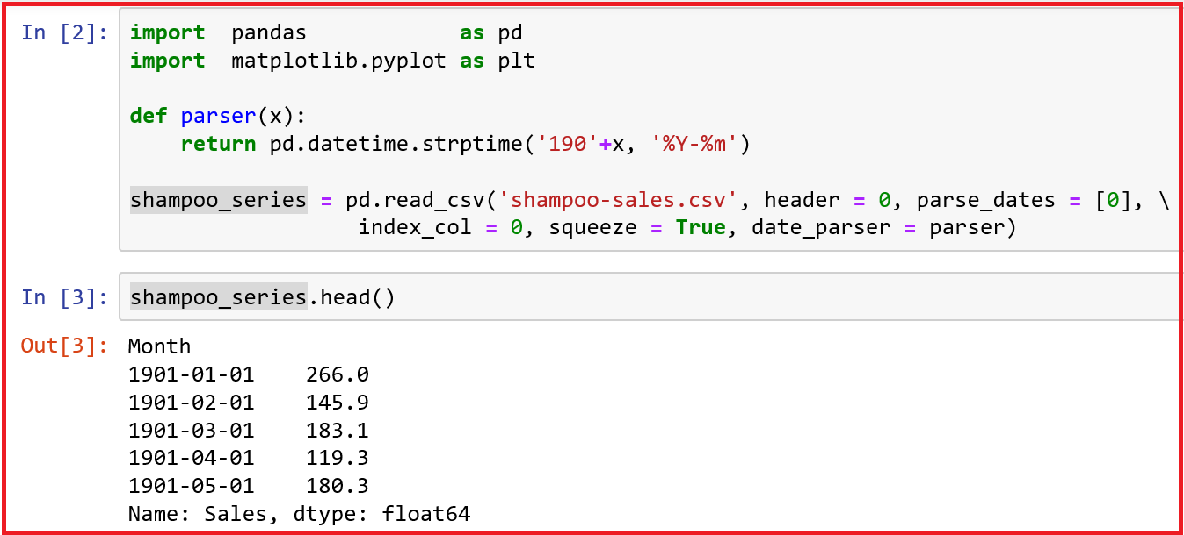

***Note****: Let us look at the arguments to the read_csv() function.*

*1.* ***header = 0*** *to indicate that the header information is present at row 1.*

*2.* ***parse_dates = True*** *to indicate that the data in the first column contains dates that need to be parsed.*

*3.* ***index_col = 0*** *to indicate that the first column contains the index information for the time series.*

*4.* ***squeeze = True*** *to indicate that we have one data column and we are interested in a Series and not a Data Frame.*

*5.* ***date_parser = parser****, user defined function to parse date when the date format cannot be inferred from the data set.*

* *We have defined a function, parser() to accept date portion in the format 'y-m' where y is a single digit to denote the last digit in the year and m denotes the two-digit numerical month.*
* *Using the strptime() of pandas' datetime() subpackage, we add '190' to the last digit of the input date field before converting to standard date time format.*
* *Show the original values and the lag values.*

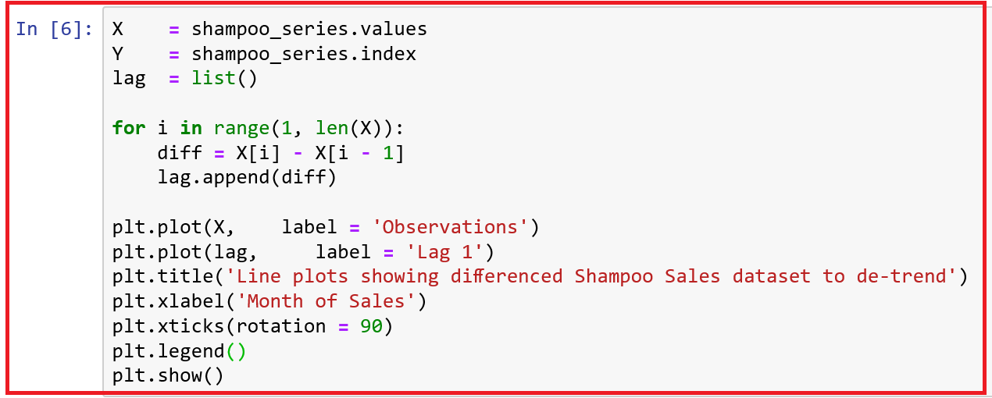

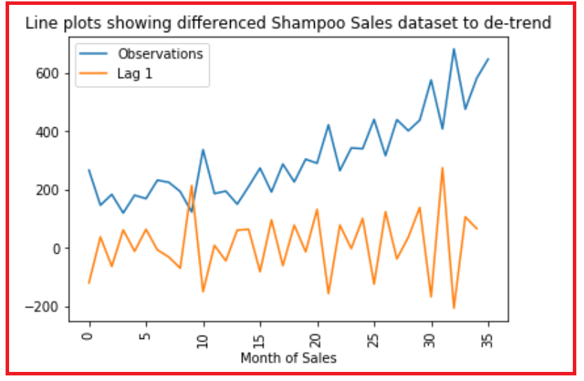

**Inference**:

* We observe that there is an increasing trend in the sales for the original observations.
* There is no obvious trend in the sales after differencing the data (lag 1 of the data).

## SEASONALITY AND HOW TO DE-SEASONALIZE?

**Seasonality**

1. *Seasonal variation or seasonality are cycles that repeat regularly over time.*
2. *By plotting and reviewing the data, you can determine if there is any seasonality in the data.*
3. *Once the seasonality is identified, it can be modelled.*
4. *When you remove the model of seasonality from the time series, it is called de-seasonalizing or seasonal adjustment.*

**Why de-seasonalise?**

* Understanding the seasonal component in time series can improve the performance of time series modelling.
* Identifying and removing the seasonal component from the series can result in a clearer relationship between the input and output variables. This will enable us

1. *to understand the relative effect of 12 months.*
2. *to understand long term movement of the series after seasonal effect is eliminated.*

**Various types of seasonality**

1. *Time of day*
2. *Daily*
3. *Weekly*
4. *Monthly*
5. *Yearly*

**How do you determine if there is seasonality?**

* Plot and review the data at different scales, with the addition of trend lines.

**How do you remove seasonality?**

* The process of removing seasonality from the time series is called seasonal adjustment or de-seasonalizing.
* A time series where the seasonal component has been removed is called seasonal **stationary**. A time series with clear seasonal component is called as **non-stationary**.

**Methods of removing seasonality**

1. Differencing is the simple method of seasonal adjustment.
2. Modelling method: Model the seasonal component directly and then subtract it from the observations.

**Example 1 - Minimum Daily Temperatures dataset**

*We use the Minimum Daily Temperatures dataset which describes the minimum daily temperature over 10 years (1981 - 1990) in the city of Melbourne, Australia.*

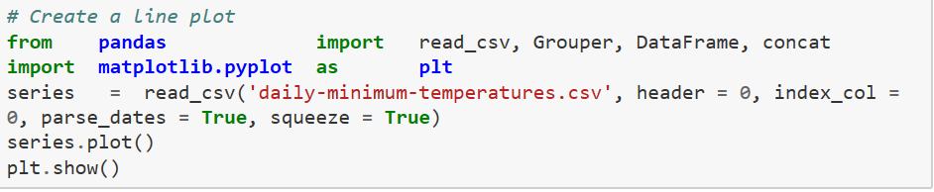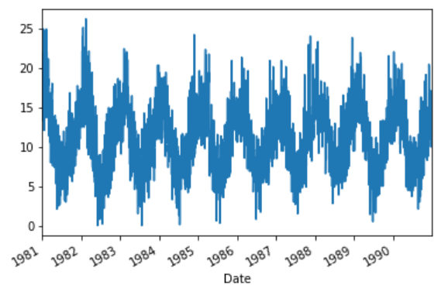

**Inference**

* + *Here we observe a pattern within each year indicating a seasonal effect. We observe that the temperatures across various years do not vary much and there is no definite increasing or decreasing trend.*
  + *We can draw a boxplot to check the variation across months in a year. It appears that we have a seasonal component each year showing swing from summer to winter. We have used 1990 here.*

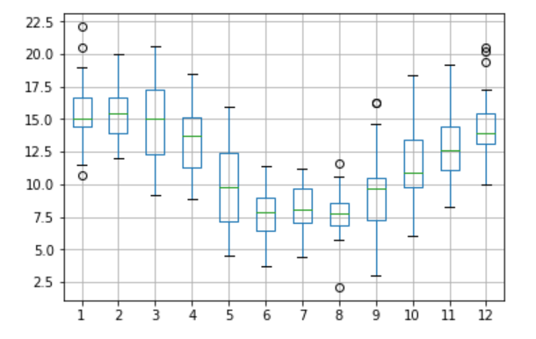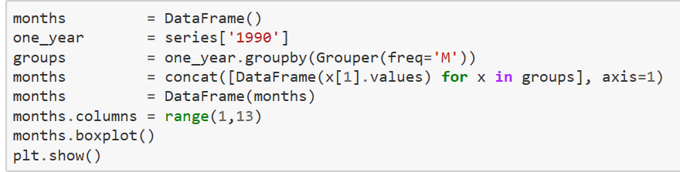

* + *We group the Minimum Daily Temperatures dataset by years. A box and whisker plot is then created for each year and lined up side-by-side for direct comparison. We don’t see any substantial difference between years.*

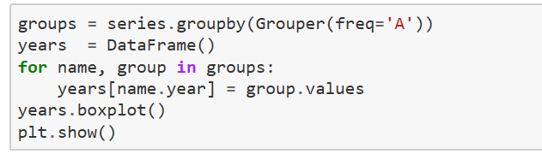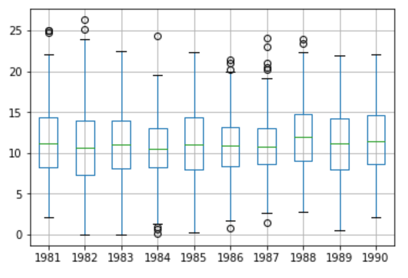

**Seasonal adjustment with differencing**

* + *We use the monthly average minimum temperatures from the same month in the previous year to adjust the daily minimum temperature dataset. We skip the first year of data.*

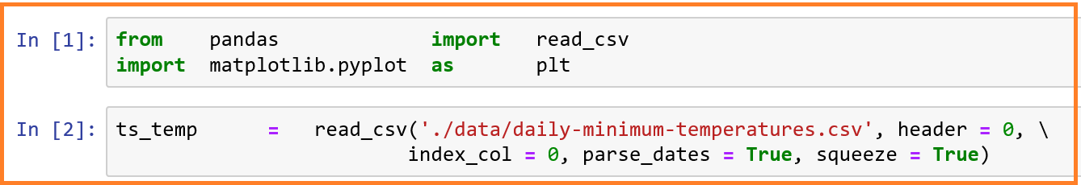

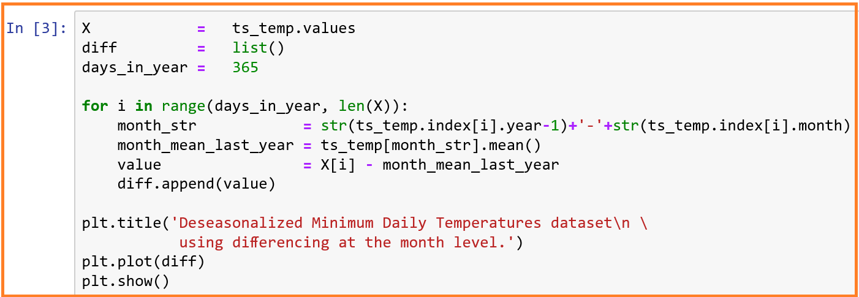

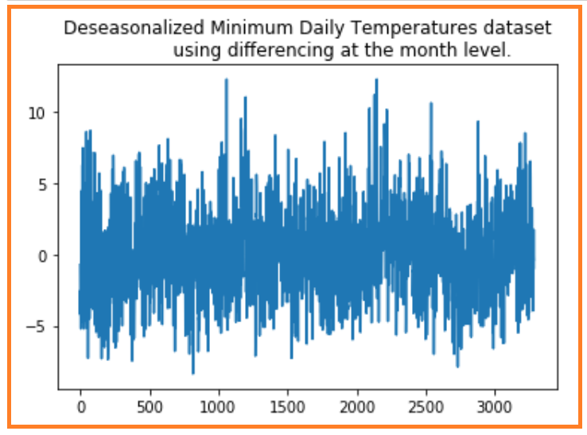

*We have created a seasonally adjusted dataset and plotted the results. This example takes care of daily fluctuations in the previous year and errors due to February 29 in leap years.*

**Seasonal adjustment with modelling**

* + *The seasonal component in a given time series can be approximated using a curve-fitting method.*
  + *We can model the seasonal component directly, then subtract it from the observations.*
  + *We shall fit a curve of a chosen order to our data set using the polyfit() function of the NumPy package. We can fit a polynomial curve by passing the x-axis values (integer day of the year), y-axis values (temperature values observed) and the order of the polynomial. We shall use a 4th order and hope it is sufficient for sine wave-like seasonality.*
  + *After we fit the curve, we have got a set of coefficients that represent our model. We can calculate the curve for the entire data set.*

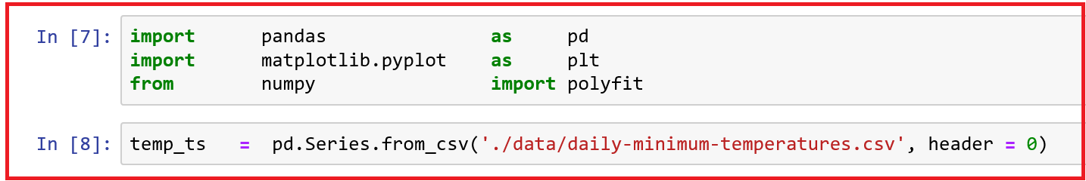



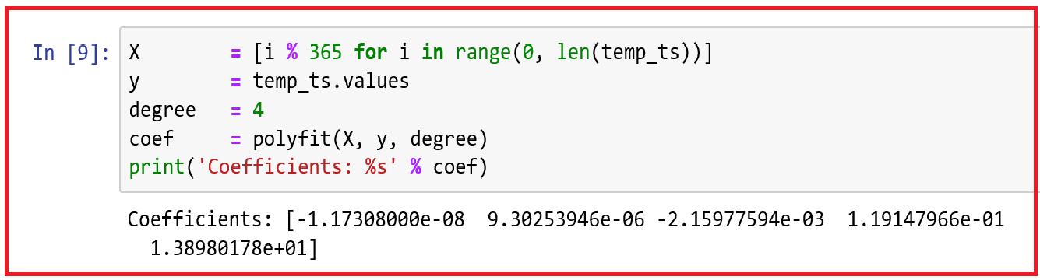

Here, temp = -1.17308e-08 * x4 + 9.3025394 e-06 * x3 - 2.15977594 e-03 * x2 +

1.19147966e-01 * x + 1.38980178

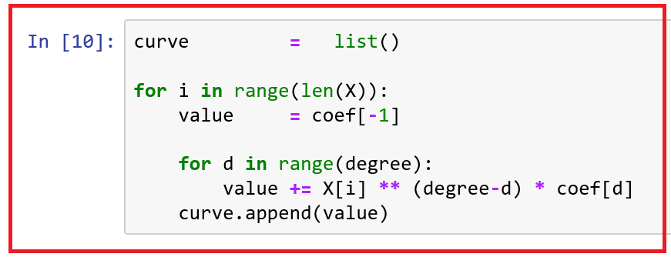

* + *We fit the curve, predict the value for each day in the dataset, and then plot the resulting seasonal model (red) over the top of the original dataset (blue).*

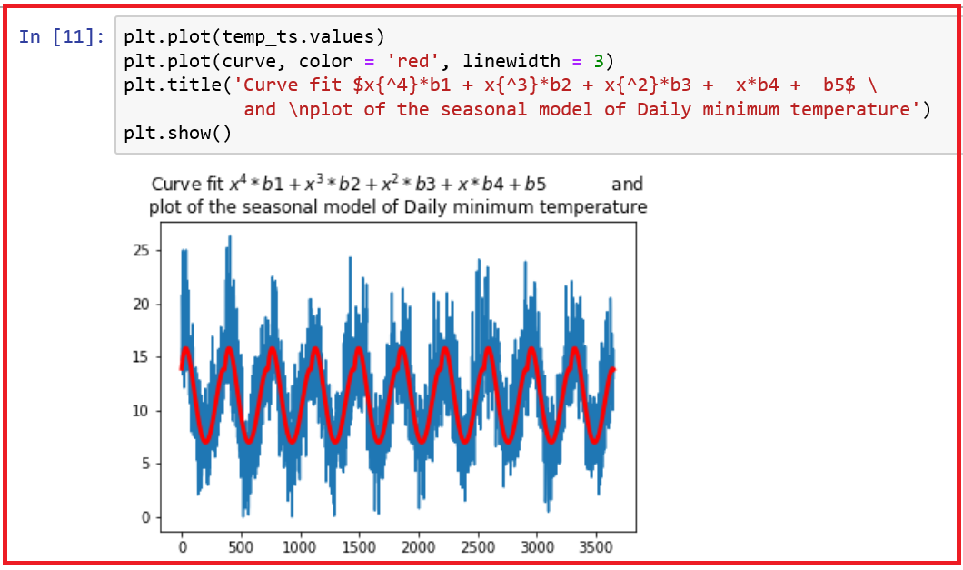

**Inference**

* + *The curve seems to be a good fit for the seasonal structure in the data.*

*Now, we adjust seasonality in the data set. We subtract the values predicted by the seasonal model from the original observations.*

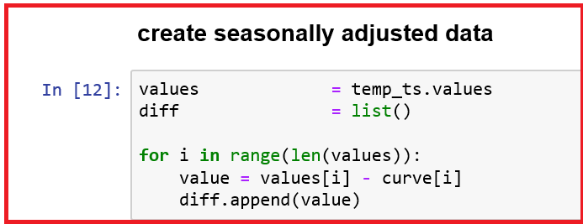

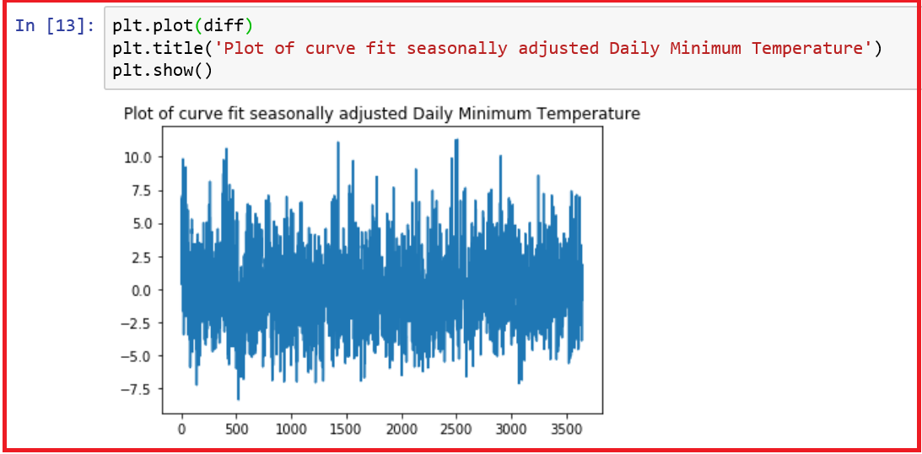

**Inference**

* + *We have created a seasonality adjusted data set as shown in the above plot.*
  + *We have created a seasonally adjusted dataset and plotted the results using both differencing method and model fitting.*

## CYCLICAL COMPONENTS

* + *Cyclical component is fluctuation around the trend line that happens due to macro-economic changes such as recession, unemployment etc.*
  + *They have repetitive patterns of Increase / decrease over years for a given period.*
  + *Periodicity of cyclical fluctuations is not constant whereas periodicity of seasonal components is constant within a calendar year.*

## IRREGULAR COMPONENTS

* 1. *The error or variability associated with the series.*
  2. *Purely Random in nature*
  3. *The part of the series that cannot be explained through systematic component and hence forecasting is not possible*
  4. *Other names for irregular component: Error or white noise*
  5. *Assumed to have a normal distribution with zero mean and constant variance.*

## Forecast Range, Accuracy and Various Requirements

* + *Time Series forecast models can both make predictions and provide a confidence interval for those predictions.*



### Forecast Range

* + ***Confidence intervals provide an upper and lower expectation for the real observation.***
  + *These are useful for assessing the range of real possible outcomes for a prediction and for better understanding the skill of the model.*
  + *For example, the ARIMA implementation in the statsmodel python library can be used to fit an ARIMA model. It returns an ARIMA Results object.*
  + *The object provides the forecast() function returns three values:*
  1. *Forecast: The forecasted value in the*
  2. *Standard Error of the model:*
  3. *Confidence Interval: The 95% confidence interval for the forecast*

### Forecast Accuracy

* + *The error in the forecast is the difference between the actual value and the forecast.*
  + *Two popular accuracy measures are RMSE and MAPE.*

### Forecast Requirements

* + *A time series model must contain a key time column that contains unique values, input columns, and at least one predictable column.*
  + *Time series data often requires cleaning, scaling, and even transformation. Data may contain corrupt or extreme outlier values that need to be identified and handled.*

***Frequency:***

* + *Data may be provided at a frequency that is too high to model or is unevenly spread through time requiring resampling for use in models. Frequencies may be too granular or not granular enough to get insights.*
  + *The pandas library in Python provides the capability to increase or decrease the sampling frequency of the time series data.*

***Resampling:***

* + *Resampling may be required if the data is not available at the same frequency that you want to make predictions.*
  + *Resampling may be required to provide additional structure or insight into the learning problem for supervised learning models.*

***Up-sampling***

* + *Increase the frequencies of the sample, example: months to days*
  + *Care may be needed in deciding how the fine-grained observations are calculated using interpolation.*
  + *The function, resample() available in the pandas library works on the Series and DataFrame objects.*
  + *This can be used to group records when down-sampling and make space for new observations when up-sampling.*



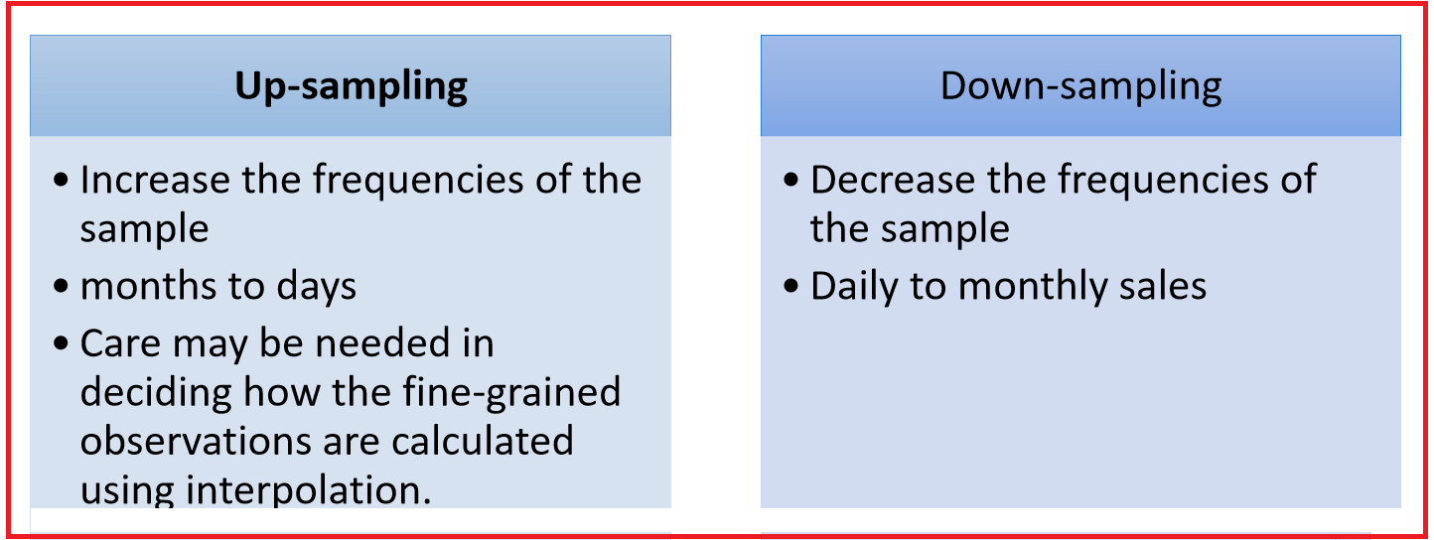

***Example for Up-sampling frequency***

* + *The observations in the Shampoo Sales are monthly. We need to up-sample the frequency from monthly to daily and use an interpolation scheme to fill in the new daily frequency.*
  + *We can use this function to transform our monthly dataset into a daily dataset by calling resampling and specifying preferred frequency of calendar day frequency or D.*

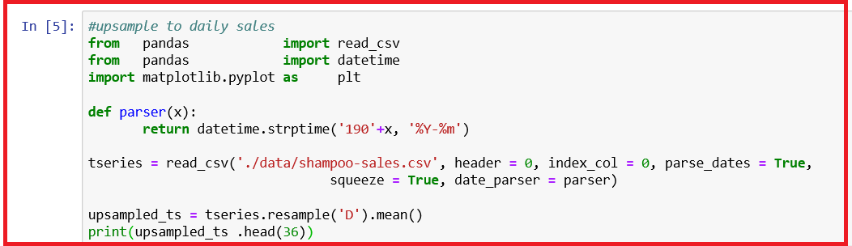

|  |  |
| --- | --- |
|  | ***Inference***   * + *We observe that the resample() function has created the rows by putting NaN values as new values for dates other than day 01.* |

* + *Next we can interpolate the missing values at this new frequency. The function, interpolate() of pandas library is used to interpolate the missing values. We use a linear interpolation which draws a straight line between available data, on the first day of the month and fills in values at the chosen frequency from this line.*

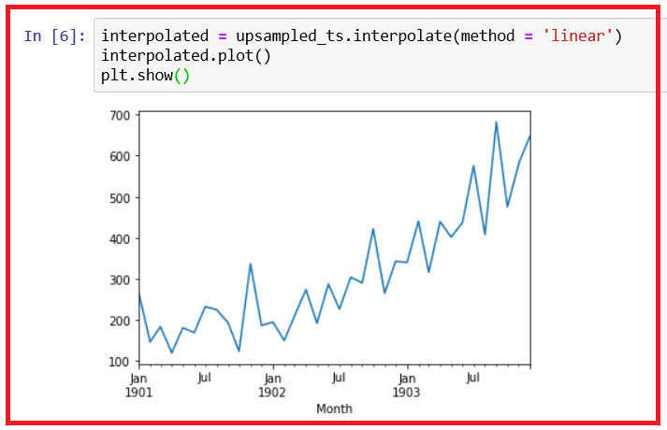

***Another common interpolation***

* + *Another common interpolation method is to use a polynomial or a spline to connect the values. This creates more curves and look more natural on many datasets.*
  + *Using a spline interpolation requires you specify the order (count of terms in the polynomial); we use 2.*

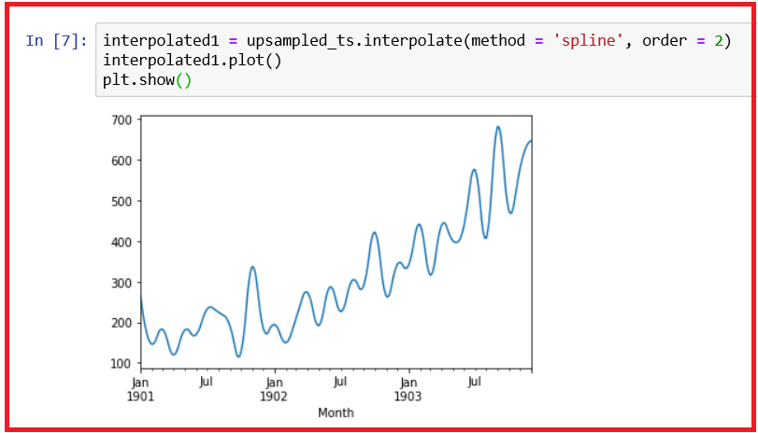

* + *Let us see the imputed values.*

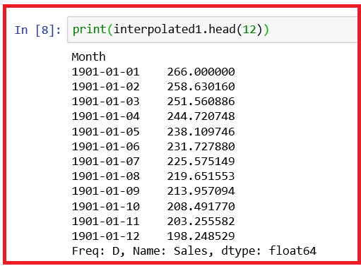

***Down-sampling Frequency***

* + *The sales data is monthly, but we prefer the data to be quarterly. The year can be divided into 4 business quarters, 3 months a piece.*
  + *The resample() function will group all observations by the new frequency.*
  + *We need to decide how to create a new quarterly value from each group of 3 records. We shall use the mean() function to calculate the average monthly sales numbers for the quarter.*

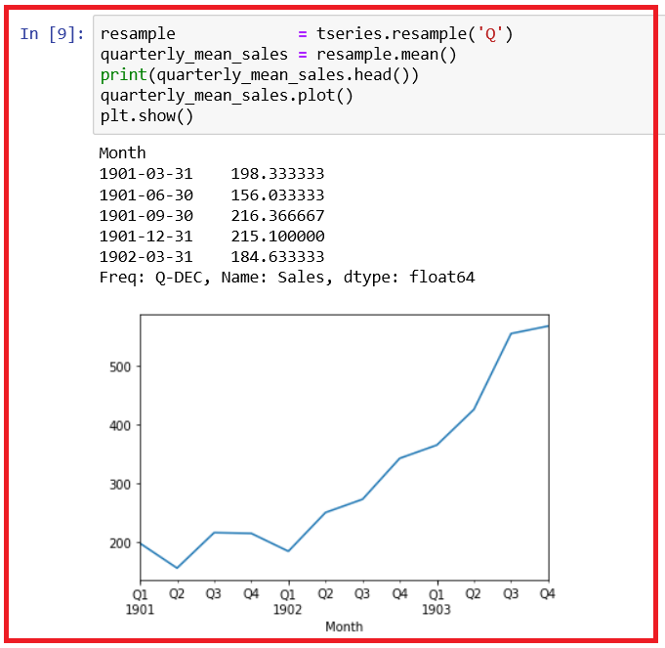

* + *We can turn monthly data into yearly data. Down-sample the data using the alias, A for year-end frequency and this time use sum to calculate the total sales each year.*

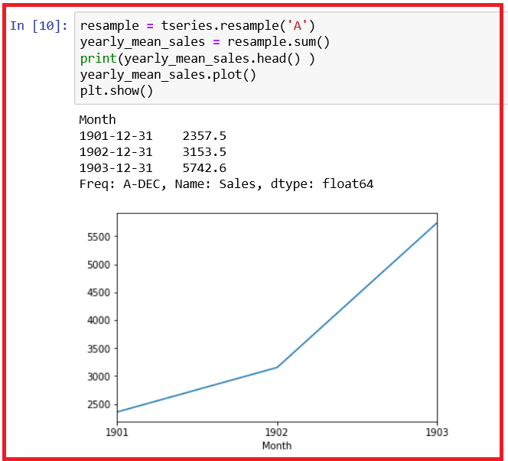

## Anomalies in time series data



### Missing values in time series data

* + *Missing values in a time series create holes in the series*
  + *No missing data is allowed in time series as data is ordered*
  + *It is simply not possible to shift the series to fill in the gaps.*



**What are the reasons for missing data?**

* + *Data is not collected or recorded*
  + *Data never existed*
  + *Data corruption*

**What are the methods to impute missing values?**

* + *When data does not have seasonality - take average of the nearest neighbours*
  + *When the data has seasonality - take average of the seasons from two or all available years*
  + *Relationship in the interval of two samples is linear - Linear interpolation*
  + *The interval between two samples is non-linear - polynomial such as Quadratic or cubic interpolation*
  + *Non-uniform spacing of samples – spline*

**Mark missing values**

* + *NaN is the default missing value marker for reasons of computational speed and convenience.*
  + *We can easily detect this value with data of different types: floating point, integer, Boolean and general object.*
  + *However, the Python None will arise and we wish to also consider that missing.*
  + *To make detecting missing values easier across different array dtypes, pandas provides functions, isna() and notna(), which are also methods on Series and DataFrame objects.*
  + *For datetime64[ns] types, NaT represents missing values. Pandas objects provide this compatibility between NaT and NaN.*

**Calculations with missing values**

*Descriptive statistics and computational statistical methods are written to take into account for missing data.*

* + *When summing data, NA(missing) values will be treated as zeros.*
  + *If the data are all NA, the result will be 0.*
  + *Cumulative methods like cumsum() and cumprod() ignore NA values by default but preserve them in the resulting arrays. To override this behaviour and include NA values, use skipna = False*
  + *A time series is a series of data points indexed in time order. Most of the times, users want to replace the missing values in time series data by neighbouring non-missing values. There may be a need for imputation or interpolation of missing values lying in between known values.*
  + *Methods of imputation for replacing missing values (meaningful values)*

**Example - Impute by taking average of the nearest neighbours**

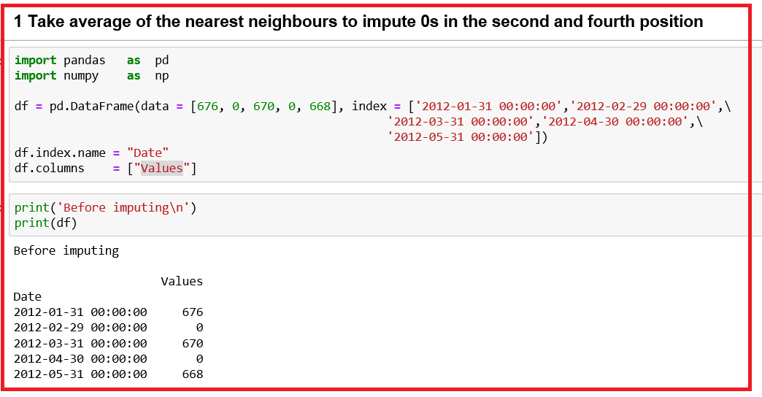

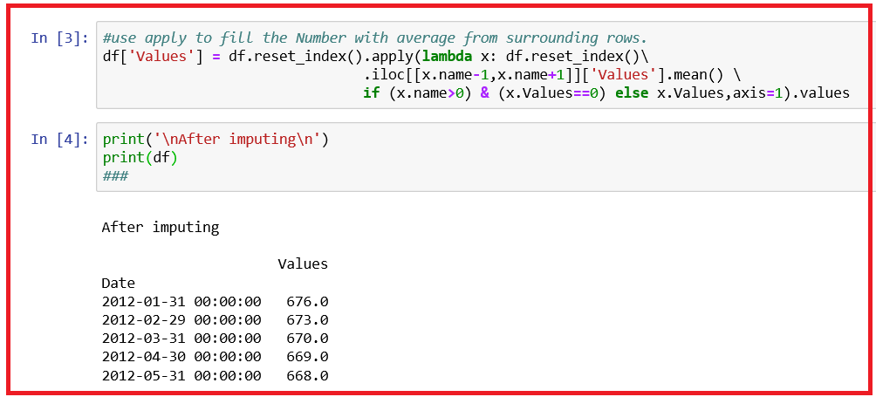

* + *We observe that the missing value at time step 2012-02-29 is imputed as 673; missing value at the time stamp 2012-04-30 is imputed as 669.*

**Example - Impute by using linear of polynomial or spline methods.**

*The file "Shoe Sales.csv", contains the shoe sales data about number of pairs sold during the period 2011 - 2015.*

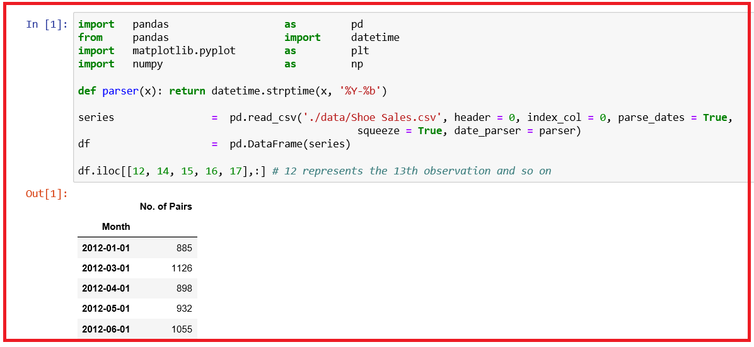

* + *In May 2012, the number of pairs sold was 932. Let us replace this with missing value and try to interpolate.*
  + *Since the data has monthly frequency, we can resample at a shorter frequency such as day, Daily to get a better prediction.*
  + *Some of the alias for time series frequency to be used in resample():*
  1. *B: Business Day frequency*
  2. *D: Calendar Day frequency*
  3. *M: Month End frequency*
  4. *MS: Month Start frequency*
  5. *Q: Quarter End Frequency*
  6. *QS: Quarter Start Frequency*
  7. *H: Hourly Frequency*
  8. *A: Year End frequency*

*http://pandas.pydata.org/pandas-docs/stable/timeseries.html#offset-aliases*

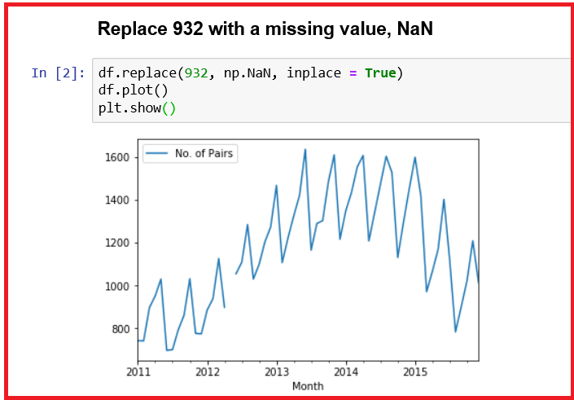

* + *Pandas dataframe.interpolate() is used to fill NA values in the data frame or series. Methods parameter accepts various values such as linear, quadratic, cubic, polynomial, spline etc.*

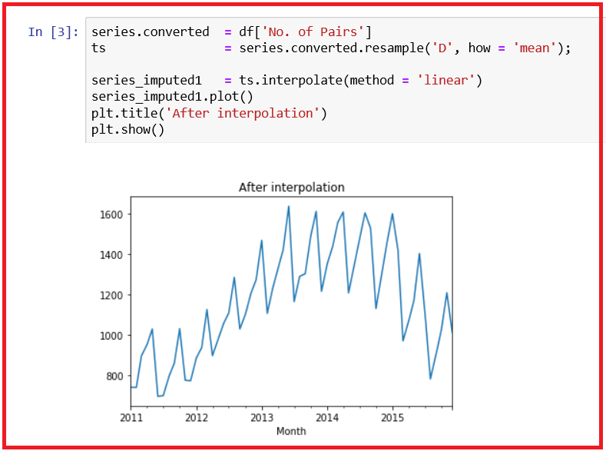

* + *Print original and imputed values.*

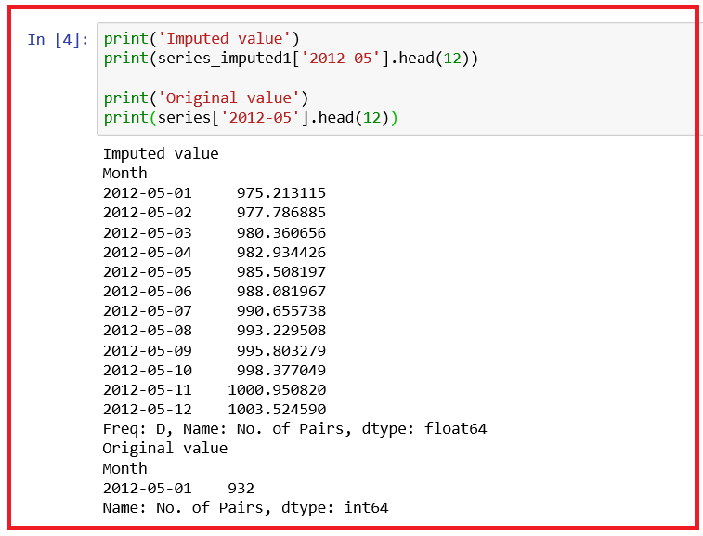

### Outliers in Time Series data

* + *Data may contain corrupt or extreme outlier values that need to be identified and handled.*
  + *Detection of outliers in time series is difficult.*
  + *If a trend is present in the data, then usual method of detecting outliers by boxplot may not work.*
  + *If seasonality is present in the data, one particular season's data may be too small or too large compared to others.*
  + *Decomposition helps in identifying unusual observations.*
  + *Outliers cannot be eliminated - they need to be imputed as closely as possible by using the knowledge gained from decomposition.*

# FORECAST METHODS



## Naïve Approach

* + *Naive forecast is the most recent value of the series.*
  + *In case of seasonal series, the seasonal naive forecast is the value from the most recent identical season.*
  + *Three properties of a good technique for making a baseline forecast:*
  1. *Simple: Forecast method must require little or no training.*
  2. *Fast: Forecast method is quick to implement and computationally trivial to make a prediction.*
  3. *Repeatable: Forecast must produce the same output given the same input.*
  + *Naive Forecast uses the value at the previous time step (t-1) to predict the expected outcome at the next time step (t+1).*
  + *This satisfies the three above condition as for a baseline forecast. This method is used as a baseline model, any model performing better than this baseline model is considered for selection.*
  + *Ref: https://machinelearningmastery.com/persistence-time-series-forecasting-with-python/*
  + *We shall use data set containing the Monthly totals of international airline passengers, 1949 to 1960. Count represented in 1000s.*

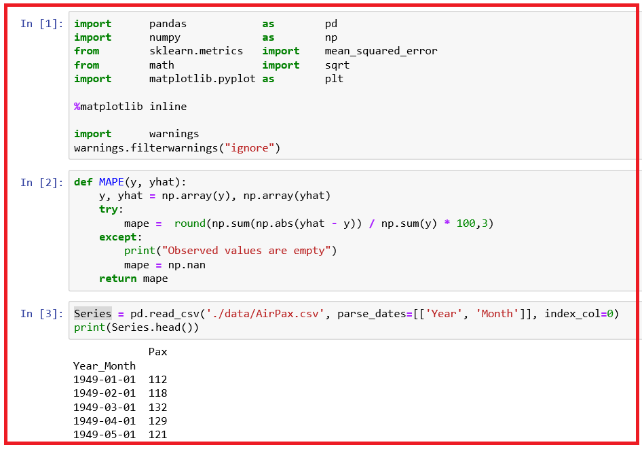

* + *We create a lagged representation meaning given a observation at t-1, predict the observation at t + 1. So, t-1 is the input and t+1 is the output.*

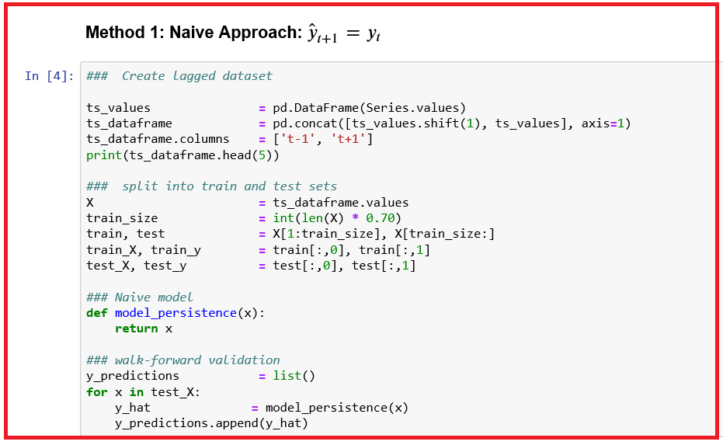

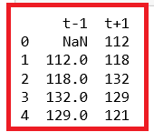

* + *We observe that the first row (index 0) need to be discarded as there was no observation prior to the first observation to use to make the prediction.*
  + *We shall keep the first 70% of the observations for training and the remaining 30% for evaluation. During the split, we exclude the first row of data with the NaN value.*
  + *We can define our naive model as a function that returns the value provided as input since the value to be predicted is given as the previous value! For example, if the t-1 value of 112 is provided, then the model returns this as the prediction.*
  + *We iterate through the test data set time step by time step to get the predictions.*
  + *Plot to show the training dataset, test data set and predicted values.*

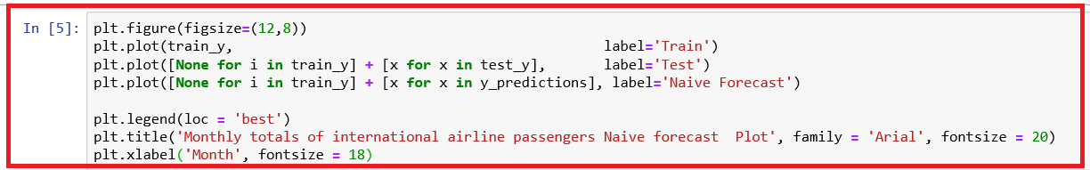

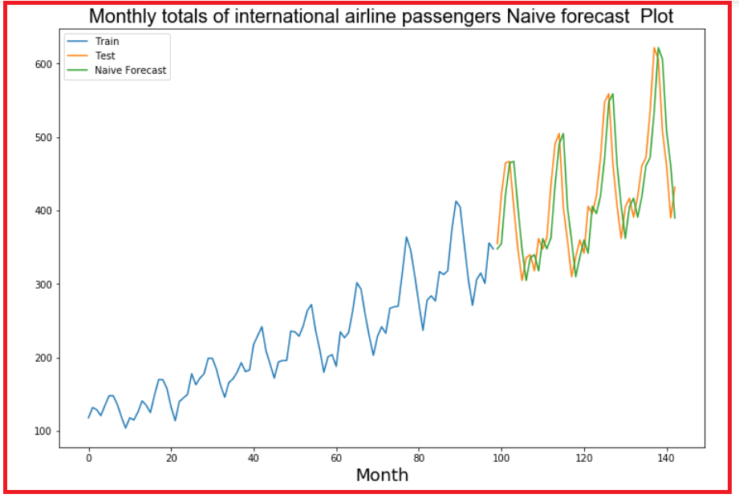

* + *From the plot, we observe that the model is 1-step behind the reality. This is a rising trend and month-to-month noise in the sales figures, implying the limitations of the persistence technique.*
  + *Once the predictions are made, we calculate both RMSE and MAPE and store this in a data frame, resultsDF for easy comparison.*

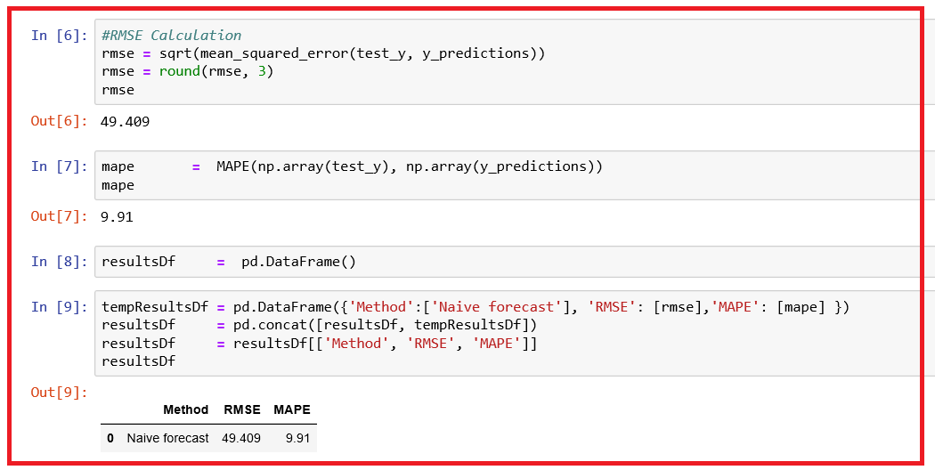

## Regression on Time

* + *Linear regression is one of the models used for time series prediction. The model uses the previous observation of the variable of interest itself to predict the current one.*
  + *This is used when trend is more pronounced in the data.*
  + *http://mariofilho.com/create-simple-machine-learning-model-predict-time-series/*
  + *We shall use data set containing the Monthly totals of international airline passengers, 1949 to 1960. Count represented in 1000s. We shall apply linear regression model to predict the count of airline passengers.*

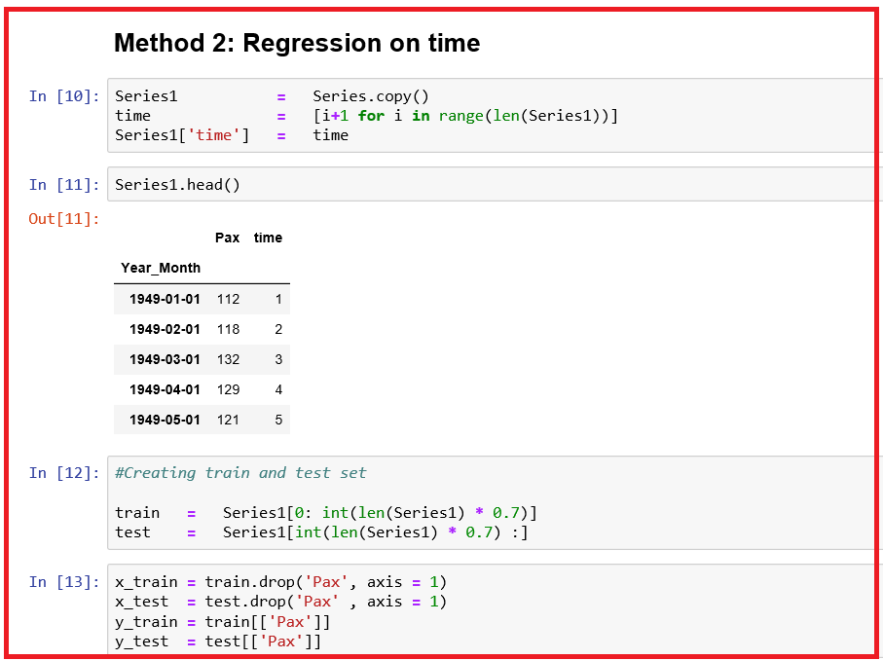

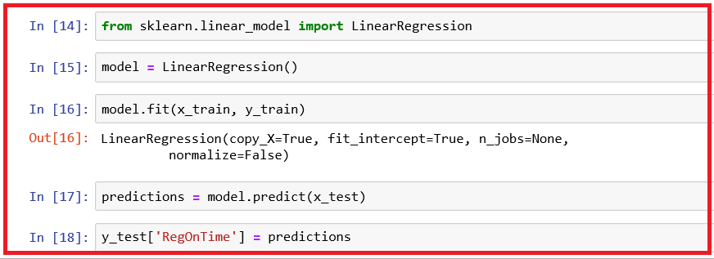

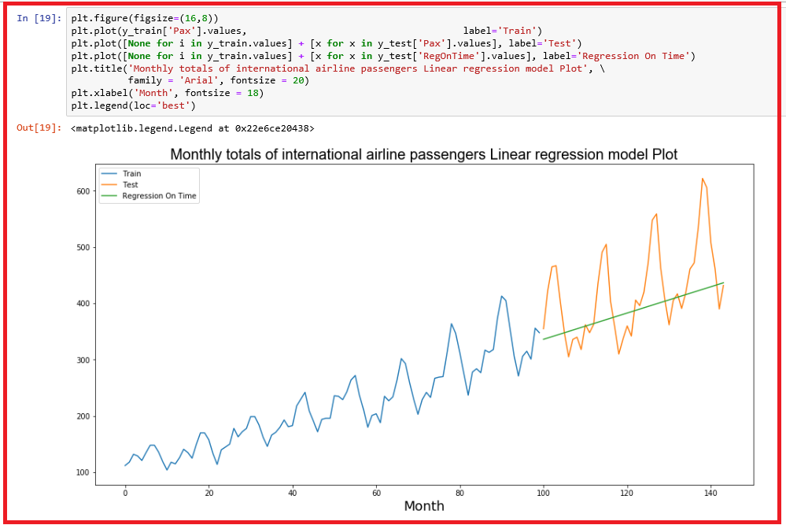

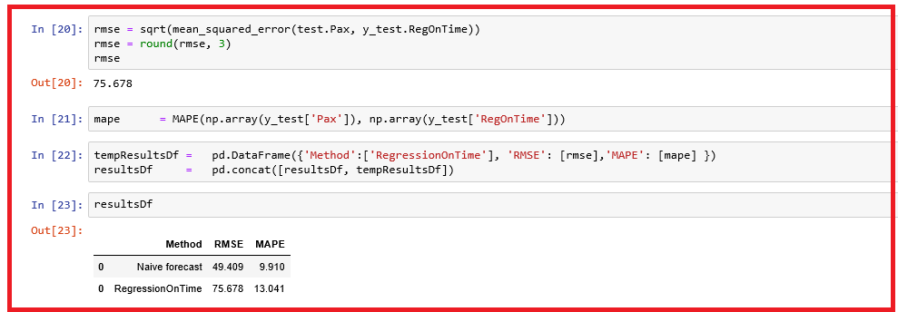

* + *We observe that there is a wide gap between the actual and forecasted values. We shall compute RMSE and MAPE now.*
  + *Our linear regression model is not better than the Naïve forecast model.*

## REGRESSION ON TIME WITH SEASONAL COMPONENTS

* + *There are many situations where we use regression with seasonal data such as hourly, weekly, monthly and quarterly, annual data where the seasons influence the trend.*
  + *In this approach, we add*
  1. *categorical variables representing the season such as month (!2 months represented by m1, m2, ..., m12). We convert them to dummy variables.*
  2. *a variable, time which lists the time periods sequentially ignoring the month.*
  + *Construct a multiple linear regression model using the predictor variables:*
  1. *Time*
  2. *monthseasonality_m1, monthseasonality_m2, …, upto m12*
  + *and Pax as the dependent variable.*

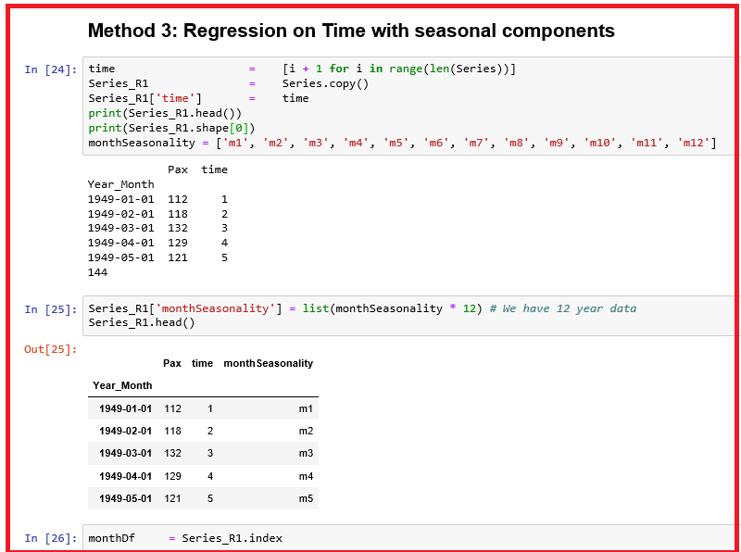

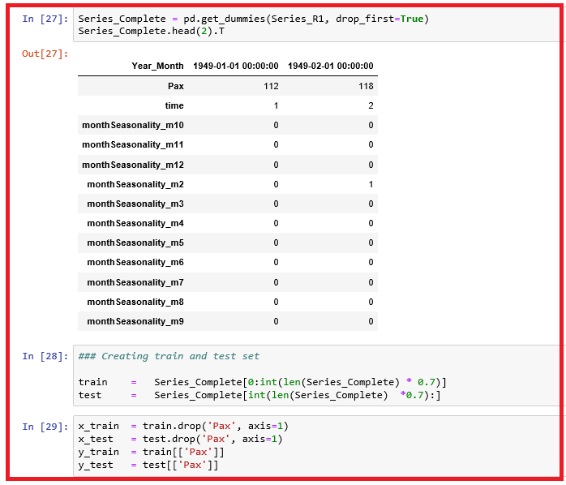

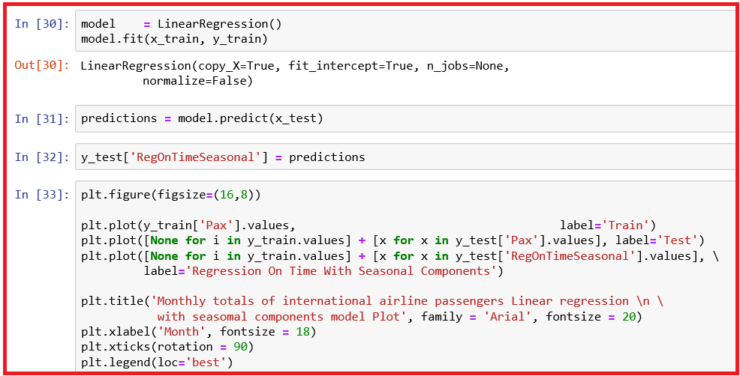

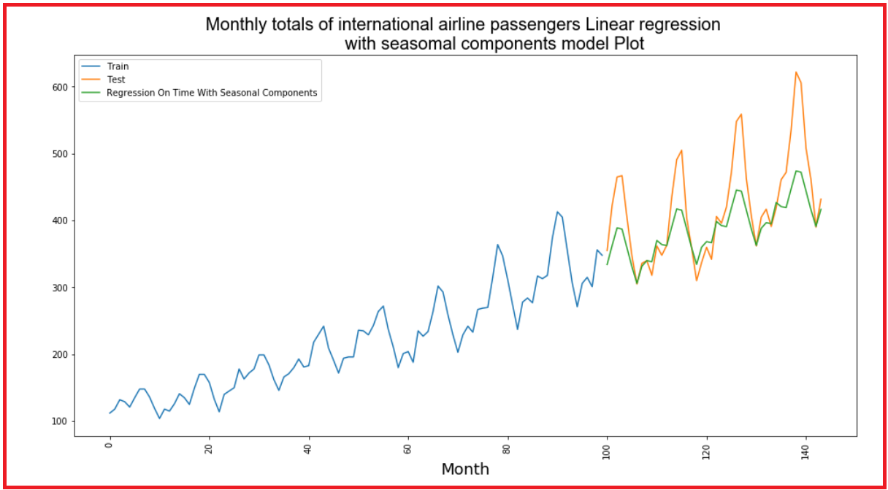

* + *We observe that gap between the actual and forecasted values is narrower than other models so far. We shall compute RMSE and MAPE now.*

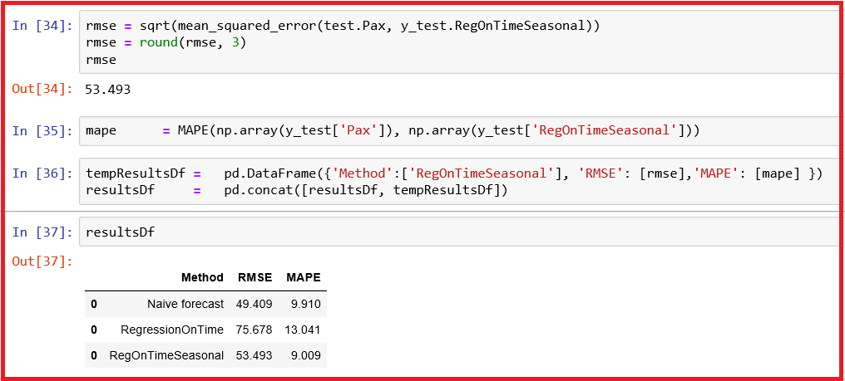

* + *Our linear regression model with seasonal components is better than the Regression on Time model and slightly inferior to Naïve forecast model based on RMSE values.*

## Simple Average

* + *In simple average method, the forecasts of all future values are equal to the average of the historical data.*
  + *yEst  = mean(y1, y2, ..., yT) where the y1, y2, ..., yT denotes the historical data, yEst is the estimate of y based on the historical data.*

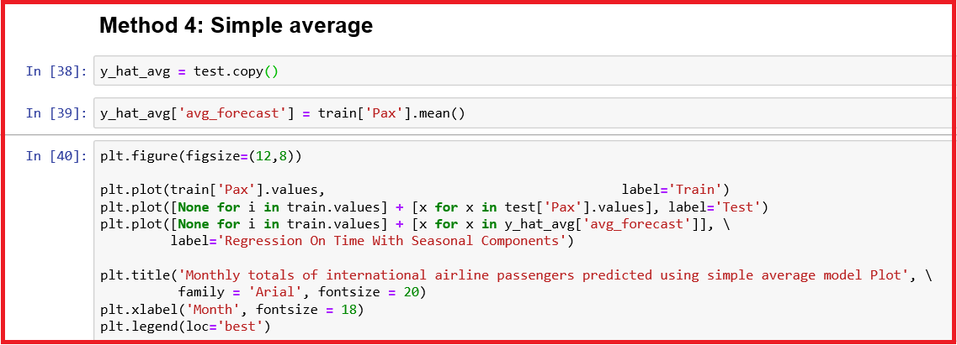

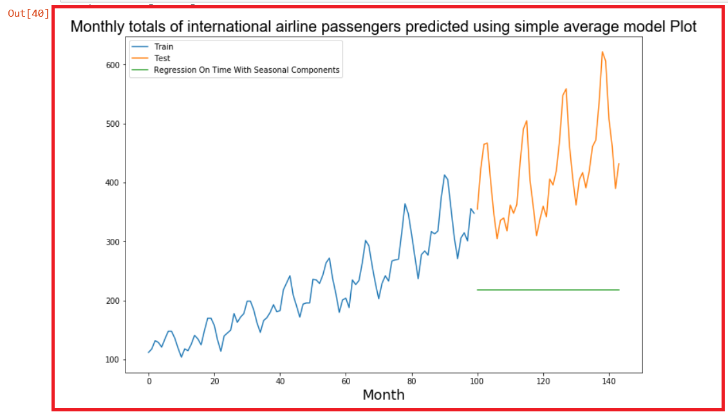

* + *We observe that there is a wide gap between the actual and forecasted values. We shall compute RMSE and MAPE now.*

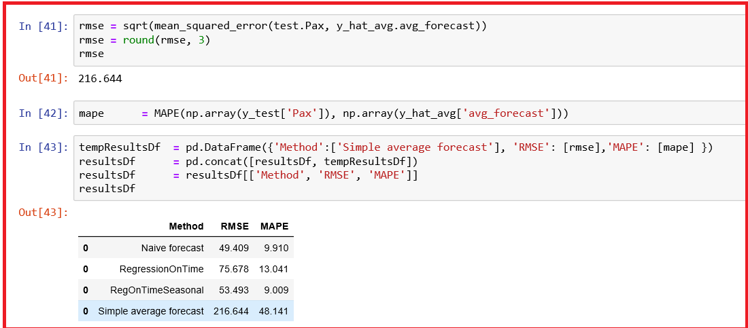

* *Our simple average model is the worst model we have seen so far and Naïve model is better than other three models.*
* *We shall try Moving Average model next.*

## Moving Average

* *Moving Average Smoothing is a naive and effective technique in time series forecasting.*
* *Smoothing is a technique applied to time series to remove the fine-grained variation between time steps.*
* *Calculating a moving average involves creating a new series where the values are comprised of the average of raw observations in the original time series.*
* *This method is suitable for univariate time series without trend and seasonal components*
* *Moving averages can be used to quickly identify whether the data is moving upward or downward depending on the pattern captured by the moving average. A moving average method is used to smooth out regularities to easily recognize trends. This method is used for visualisation and simple forecasting.*
* *The moving average forecast model is based on the assumption of a constant model.*
* *We estimate the single parameter of the model at time, t as an average of the last m observations, where m is the moving average interval.*

*Ft+1 = 1 / m (∑yk) where k ranges from t + 1 – m to t*

* *In moving average model, an important decision that one takes is to set the number of periods, m. The forecast accuracy depends on m.*
* *If m is small, then the average tends to be more sensitive to recent observations or more responsive to recent trend.*
* *If m is large, the forecast will be less sensitive or response to the recent changes in the data. Since the moving average will always be centred around the range of the data points considered, it will lag behind the trend until about (m + 1) / 2 time periods.*
* *Two main types of moving averages:*

1. *Centered moving average - calculated as the average of raw observations at, before and after time, t*
2. *Trailing moving average - uses historical observations and is used on time series forecasting.*

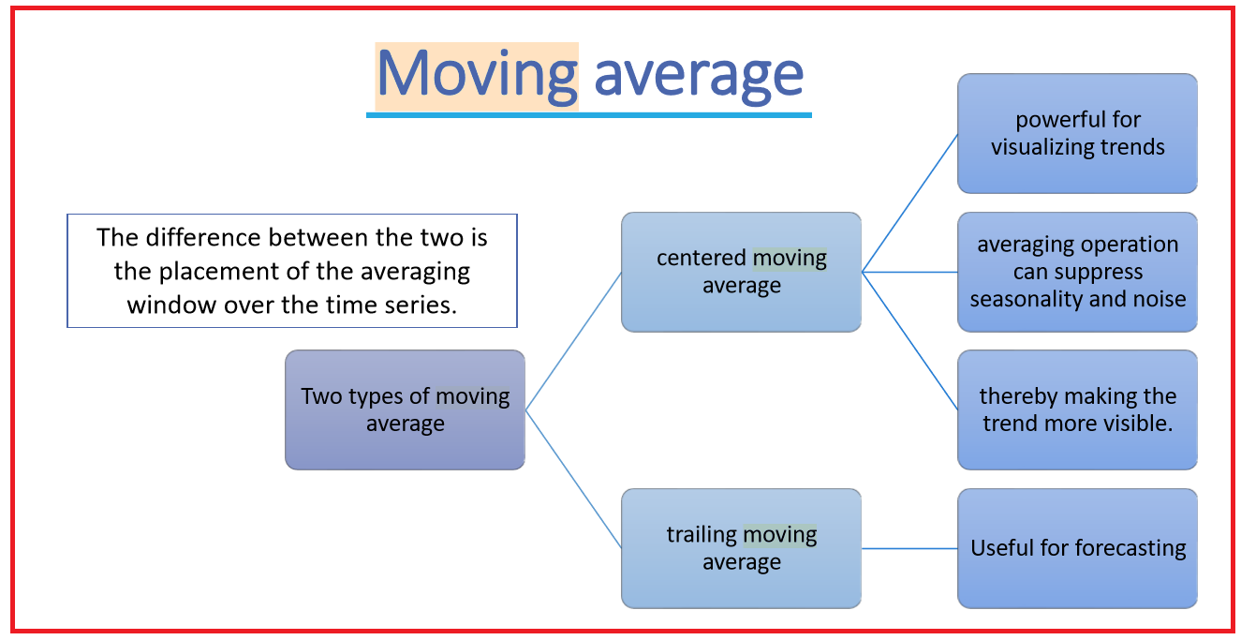

* *We shall try moving average model for our Airline passengers data set.*
* *The rolling() function on the Series Pandas object will automatically group observations into a window.*
* *You can specify the window size, and by default, a trailing window is created. Once the window is created, we can use the mean value, which forms our transformed dataset.*

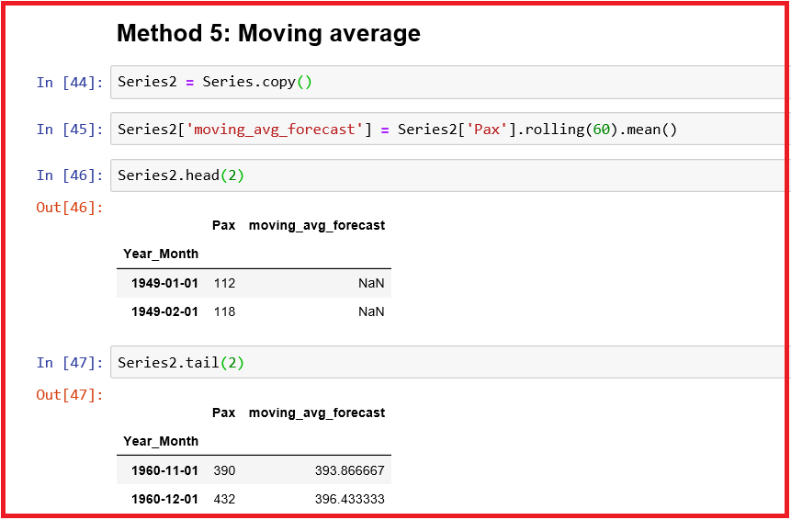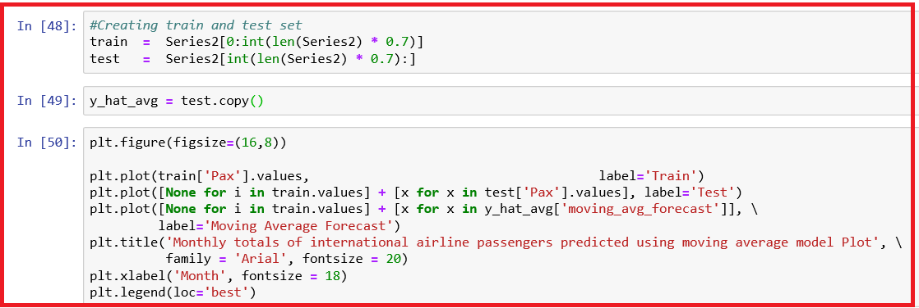

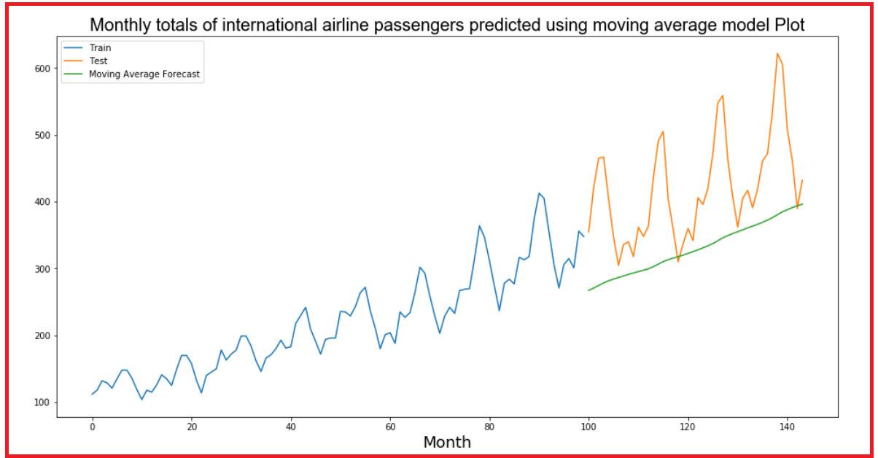

* + *We observe that there is still a wide gap between the actual and forecasted values. We shall compute RMSE and MAPE now.*

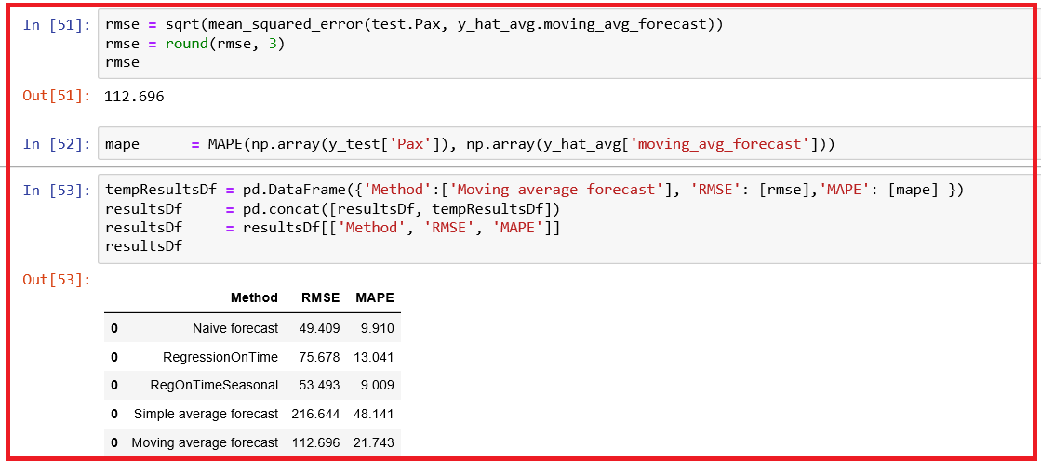

* *Our moving average model is the better than simple average model but worse than both Regression on Time and Naïve forecast model. We have seen so far Naïve model is better than other four models.*
* *We shall try Simple Exponential Smoothing model next.*

## Error, Trend and Seasonality (ETS) models

* *Exponential smoothing models for univariate time series forecasting are in use for since 1950. Only in the 21st century it is very popular.*

*Refer the book: Hyndman, Koehler, Ord and Snyder’s Forecasting with Exponential Smoothing: The State Space Approach*

*http://www.exponentialsmoothing.net/*

Very popular models are:

1. Simple or single exponential smoothing
2. Holt's linear trend method
3. Holt-Winter's seasonal method

### Exponential Smoothing methods

* *Exponential smoothing methods consist of flattening time series data.*
* *Exponential smoothing averages or exponentially weighted moving averages consist of forecast based on previous periods data with exponentially declining influence on the older observations.*
* *Exponential smoothing methods consist of special case exponential moving with notation ETS (Error, Trend, Seasonality) where each can be none(N), additive (A), additive damped (Ad), Multiplicative (M) or multiplicative damped (Md).*
* *One or more parameters control how fast the weights decay.*
* *These parameters have values between 0 and 1*

### SES - ETS(A, N, N) - Simple smoothing with additive errors

* *The simplest of the exponentially smoothing methods is naturally called simple exponential smoothing (SES).*
* *This method is suitable for forecasting data with no clear trend or seasonal pattern.*
* *In Single ES, the forecast at time (t + 1) is given by Winters,1960*
* *Ft*+1 = *𝛼 𝑌𝑡* + (1−*𝛼*) *Ft+1*
* *Parameter α is called the smoothing constant and its value lies between 0 and 1. Since the model uses only one smoothing constant, it is called Single Exponential Smoothing.*

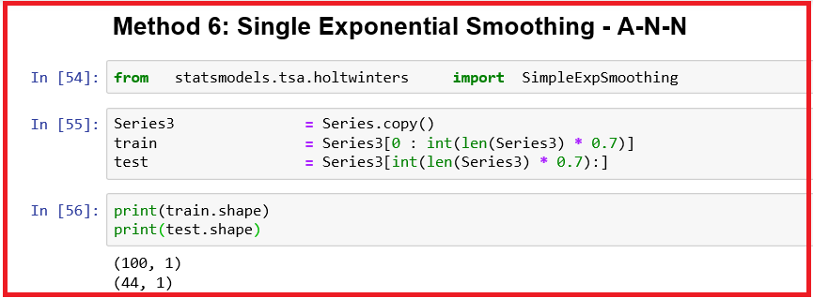

* *SimpleExpSmoothing class must be instantiated and passed the training data.*
* *The fit() function is then called providing the fit configuration, the alpha value, smoothing_level. If this is omitted or set to None, the model will automatically optimize the value.*
* *We will try with various values of 𝛼 such as 0.1, 0.5 and 0.99 and then let the model optimize 𝛼*
* *A value close to 1 indicates fast learning (that is, only the most recent values influence the forecasts), whereas a value close to 0 indicates slow learning (past observations have a large influence on forecasts).*

*— Page 89, Practical Time Series Forecasting with R, 2016.*

* *For more details, refer to:* [*https://www.amazon.com/Practical-Time-Forecasting-Hands-Analytics/dp/0997847913/ref=as_li_ss_tl?ie=UTF8&qid=1527636709&sr=8-5&keywords=time+series+forecasting&linkCode=sl1&tag=inspiredalgor-20&linkId=dcb38fa9efe5af617b48b2922c4c149f*](https://www.amazon.com/Practical-Time-Forecasting-Hands-Analytics/dp/0997847913/ref=as_li_ss_tl?ie=UTF8&qid=1527636709&sr=8-5&keywords=time+series+forecasting&linkCode=sl1&tag=inspiredalgor-20&linkId=dcb38fa9efe5af617b48b2922c4c149f)

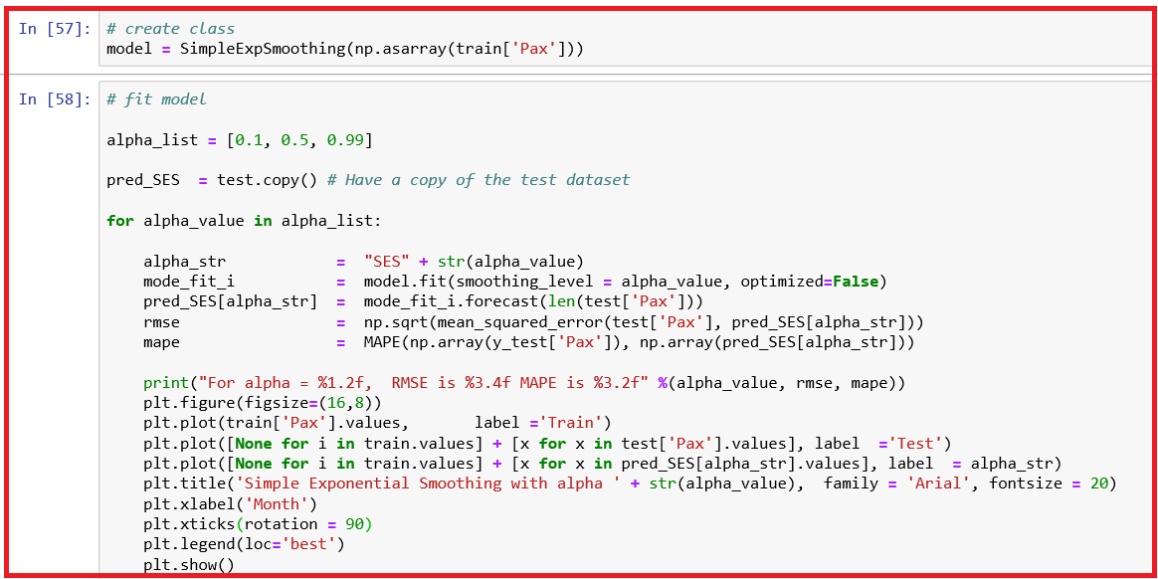

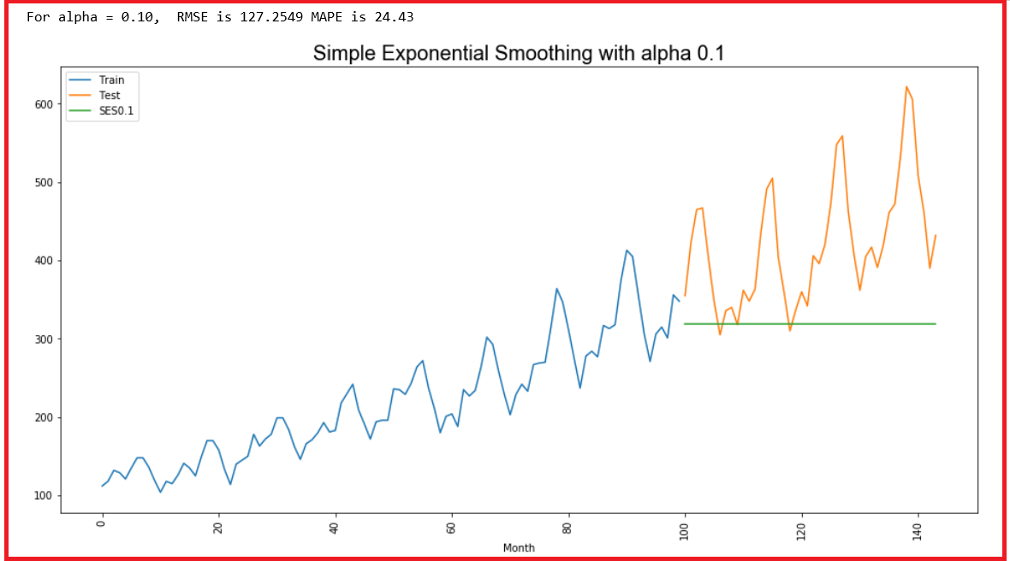

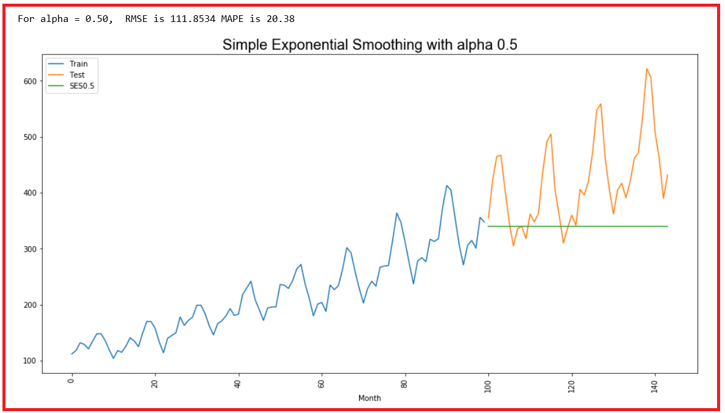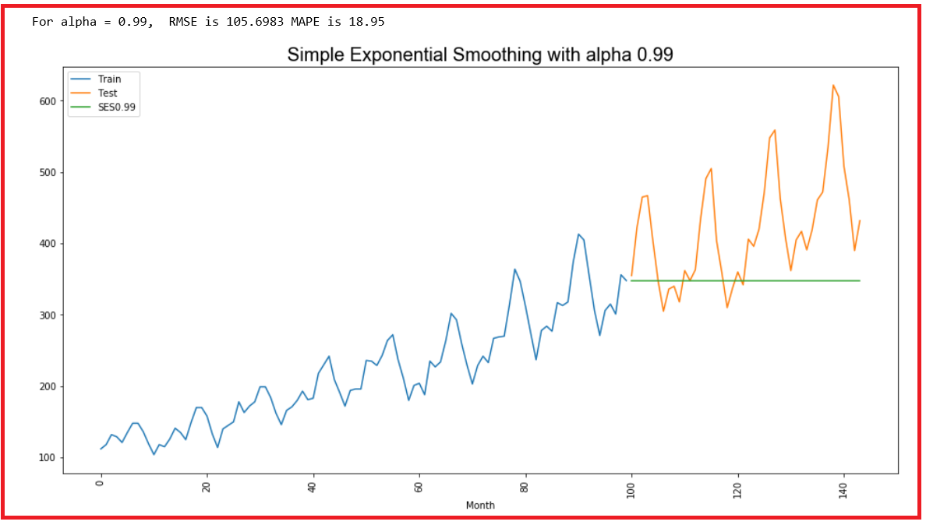

* *Let us get the optimum value for 𝛼 by omitting the value and leave it for the model to decide.*

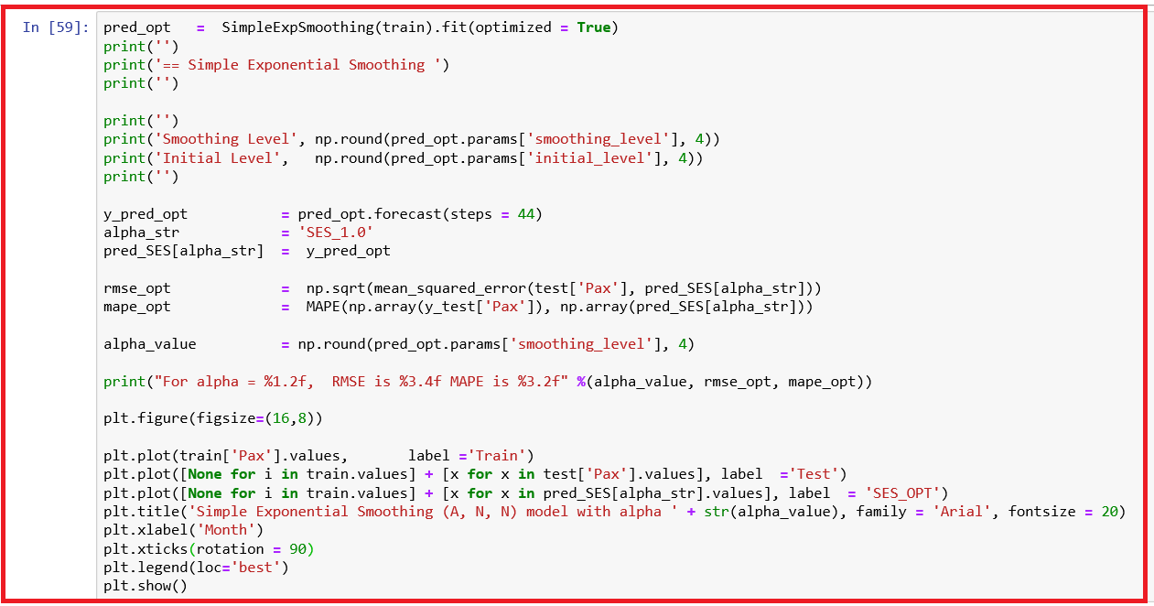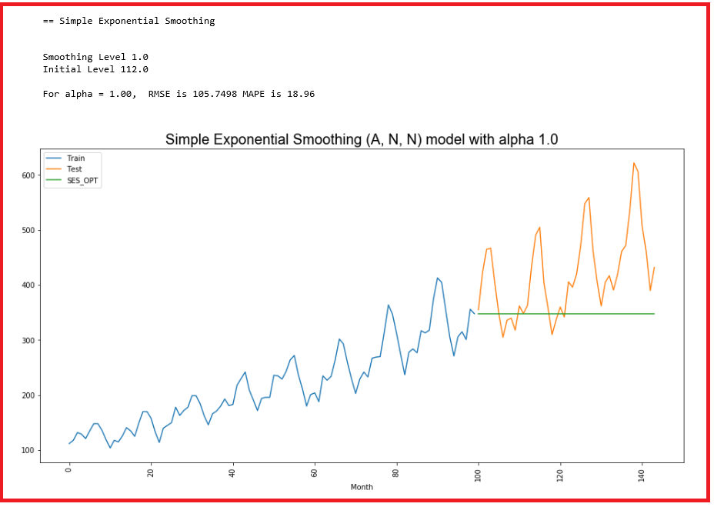

* + *We observe that there is still a wide gap between the actual and forecasted values. We shall compute RMSE and MAPE now.*

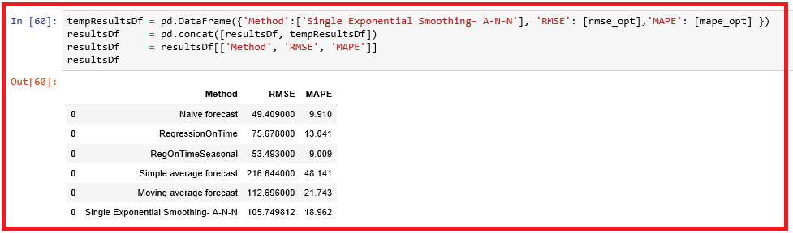

**Inference**

* *In the presence of trend, Single Exponential smoothing is inadequate as shown in the graph above.*
* *We observe that for the optimum α value, both RMSE and MAPE are smallest when compared to other α values of 0.1,0.5 and 0.99.*
* *When we compare this model performance with all the models we have tried so far, we observe that SES – ANN model performs better than Simple Average and Moving average models but worse than all the other models we have tries so far.*

### Holt - ETS(A, A, N) - Holt's linear method with additive errors

***Double Exponential Smoothing***

* *One of the drawbacks of the single exponential smoothing is that the model does not do well in the presence of the trend.*
* *This model is an extension of SES and also known as Double Exponential model*
* *Applicable when data has Trend but no seasonality*
* *Two separate components are considered: Level and Trend*
* *Level is the local mean*
* *One smoothing parameter α corresponds to the level series*
* *A second smoothing parameter 𝛽 corresponds to the trend series.*
* *Double Exponential Smoothing uses two equations to forecast future values of the time series, one for forecasting the short-term average value or level and the other for capturing the trend.*
* *Intercept or Level equation, Lt= αYt + (1−α) Ft*
* *Trend equation is given by Tt =* 𝛽 *(Lt − Lt−1) + (1−*β*) Tt−1*
* *Here, α and* β *are the smoothing constants for level and trend, respectively,*
* *0 <α < 1 and 0 <* β *< 1.*
* *The forecast at time t + 1 is given by*
* *𝐹𝑡+1 = Lt + Tt*
* *𝐹𝑡+𝑛 = Lt + nTt*

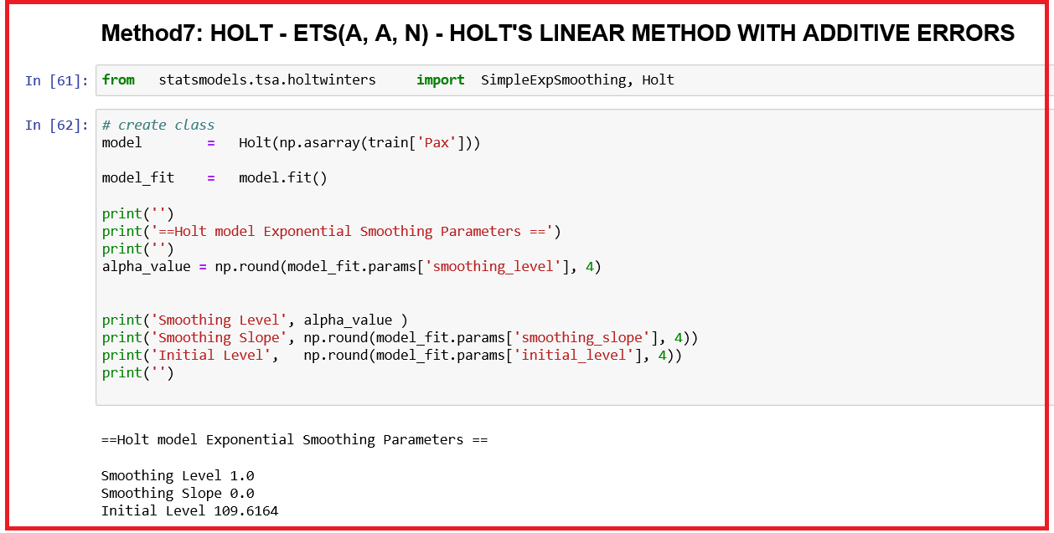

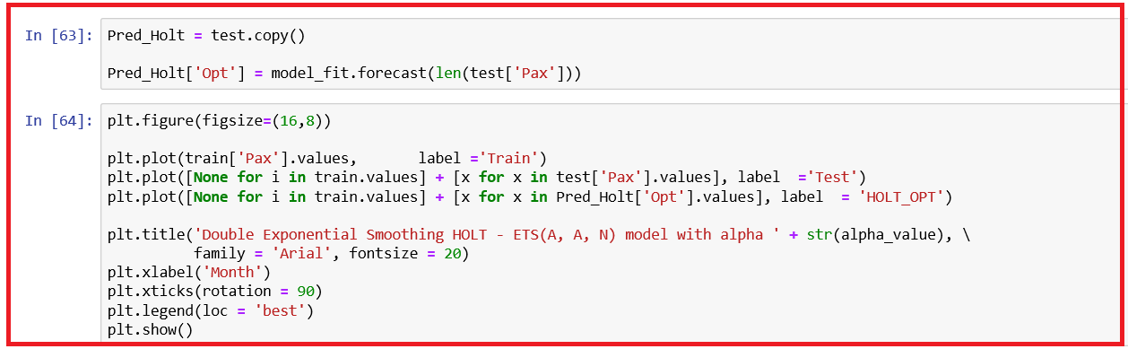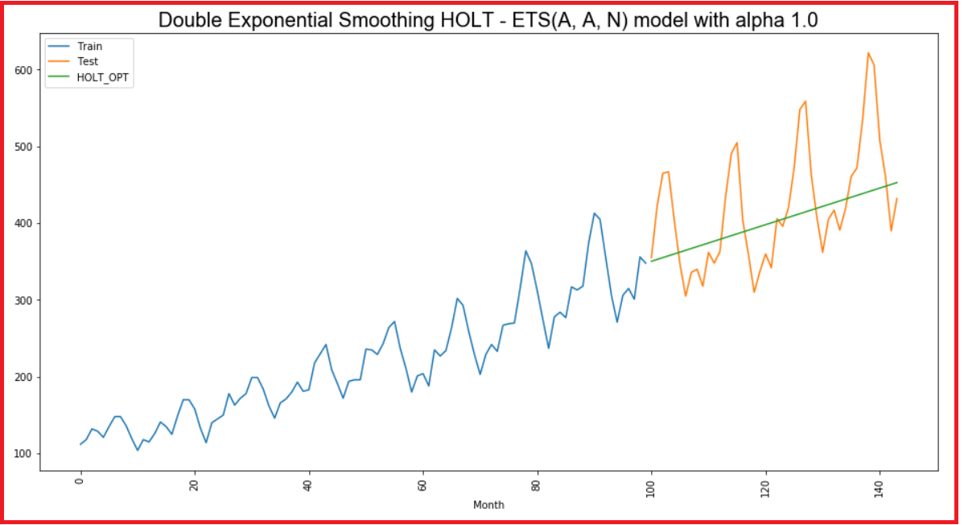

* + *We observe that there is still a wide gap between the actual and forecasted values. We shall compute RMSE and MAPE now.*

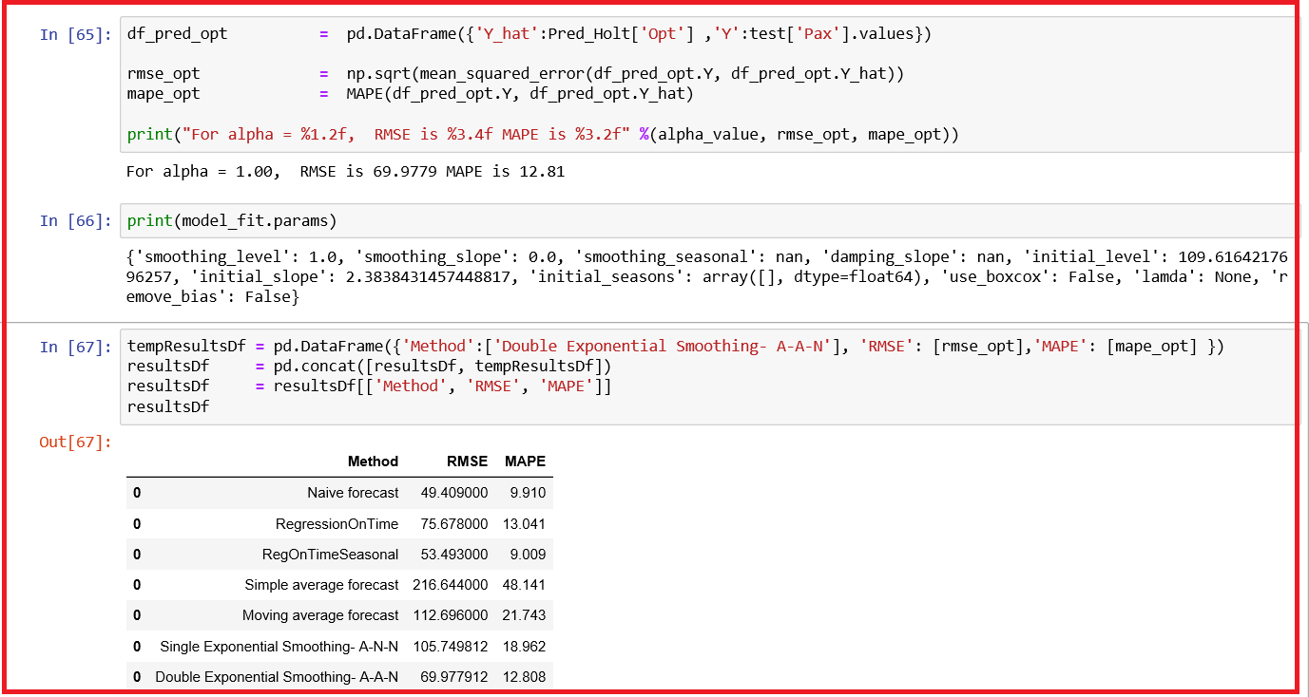

* *When we compare this model performance with all the models we have tried so far, we observe that DES – AAN model performs worse than   
  Naïve Forecast model and Regression on Time with seasonal components models but better than other models we have tries so far.*

## Holt’s Winter Seasonal Trend

* *A quick question? What about an exponential smoothing for data with a trend and seasonality? Holt-Winters model deals with such data.*
* *Moving average and single, double exponential smoothing techniques seen so far can handle data as long as the data do not have any seasonal component associated with it. These techniques when applied to data with seasonality, the fitted error values (difference between forecasted and observed values) associated with these techniques will indicate systematic error patterns that reflect the existence of seasonality. Such time series data require the use of a seasonal method to eliminate the systematic patterns in error.*

***TRIPLE EXPONENTIAL SMOOTHING (HOLT-WINTER MODEL)***

* *Triple exponential smoothing is used when the data has trend as well as seasonality,*

***Equations in Holt-Winters Additive model***

* *Level, Lt = α(yt −St−s ) + (1−α)(Lt−1 +bt−1)*
* *trend bt =* β *(Lt −Lt−1 ) + (1−* β*) bt−1*
* *Seasonal St = γ(yt −Lt) + (1−γ) St−s*
* *Forecast Ft+k = Lt + kbt + St+k−s*
* *where s is the length of the seasonal cycle, for 0 ≤ α ≤ 1, 0 ≤ β ≤ 1 and 0 ≤ γ ≤ 1.*
* *The seasonal equation picks up differences between the current level and the data at that time in the seasonal cycle. This is then added to a forecast at the same point in the cycle.*
* *We have to select the values of α, β and γ. As with the other methods, using measures such as RMSE or MAPE, we can choose the best values.*

***Initial values***

* *We need initial values of the level, trend and seasonality.*
* *In order to forecast, at least one complete seasonal cycle y1,y2,...,ys is needed.*
* *We therefore initialise Ls, bs and S1,...,Ss, then use the formulae above to make forecasts from time s onwards.*

***Starting values:***

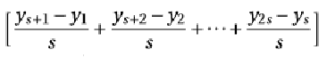 Ls = (1 / s) ∑yi

bs = (1/ s)

Si = yi - Ls,

where I ranges from 1 to s



### Holt WINTER - ETS(A, A, A) - with additive errors

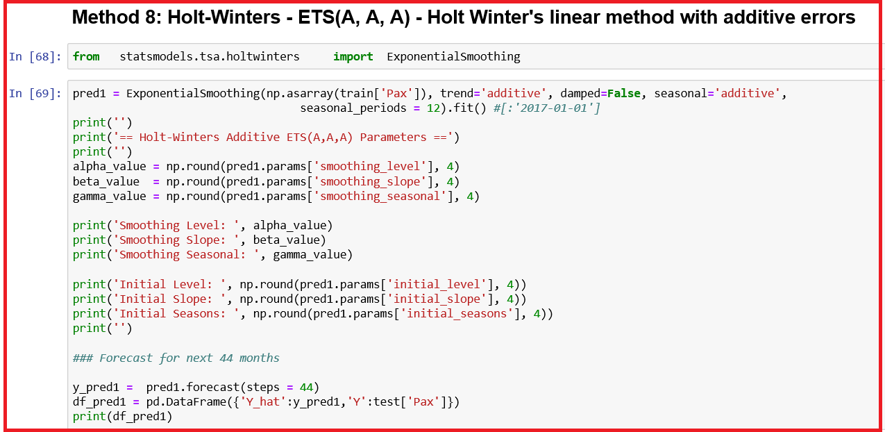

*Output is truncated!*

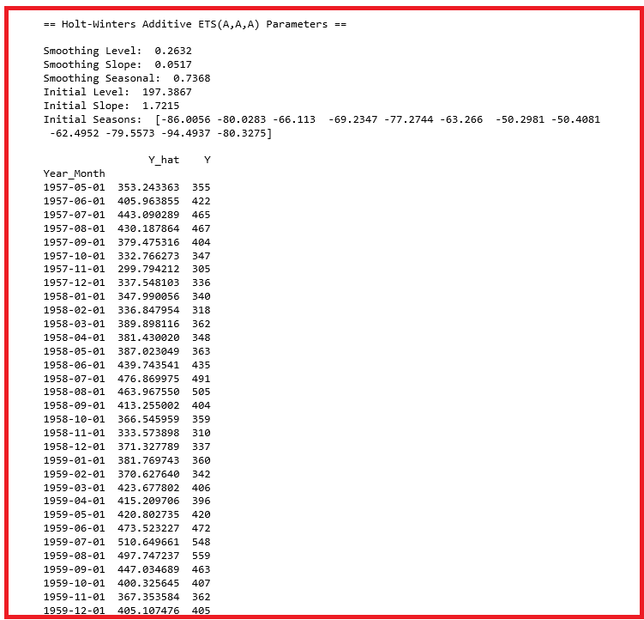

*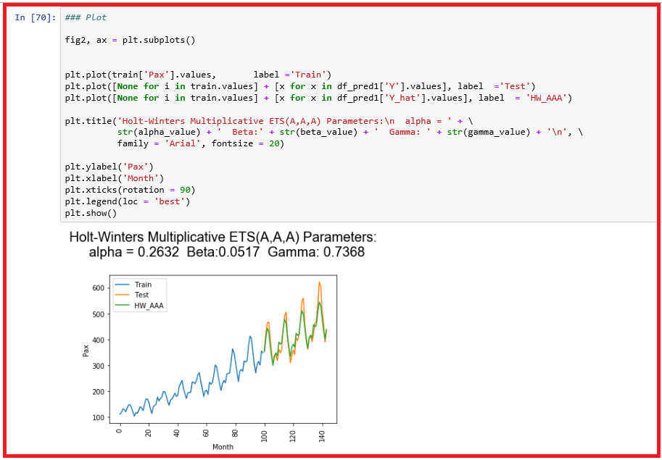We observe that there is a little gap between the actual and forecasted values. We shall compute RMSE and MAPE now.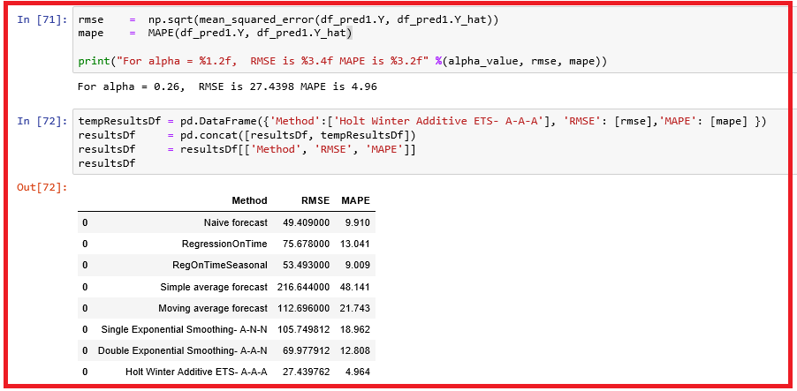*

* *We observe that HW – AAA model better than other models we have tried so far.*

***Equations in Holt-Winters Multiplicative model***

* *Level, Lt = α(yt / St−s ) + (1−α)(Lt−1 +bt−1)*
* *trend bt =* β *(Lt −Lt−1 ) + (1−* β*) bt−1*
* *Seasonal St = γ(yt / Lt) + (1−γ) St−s*
* *Forecast Ft+k = (Lt + kbt ) St+k−s*
* *where s is the length of the seasonal cycle, for 0 ≤ α ≤ 1, 0 ≤ β ≤ 1 and 0 ≤ γ ≤ 1. Initial values are the same as in additive case.*
* *Season estimates are: S1 = y1 / Ls, … Ss = ys / Ls*

### HOLT WINTER - ETS(A, M, M) - WITH MULTIPLICATIVE MODEL

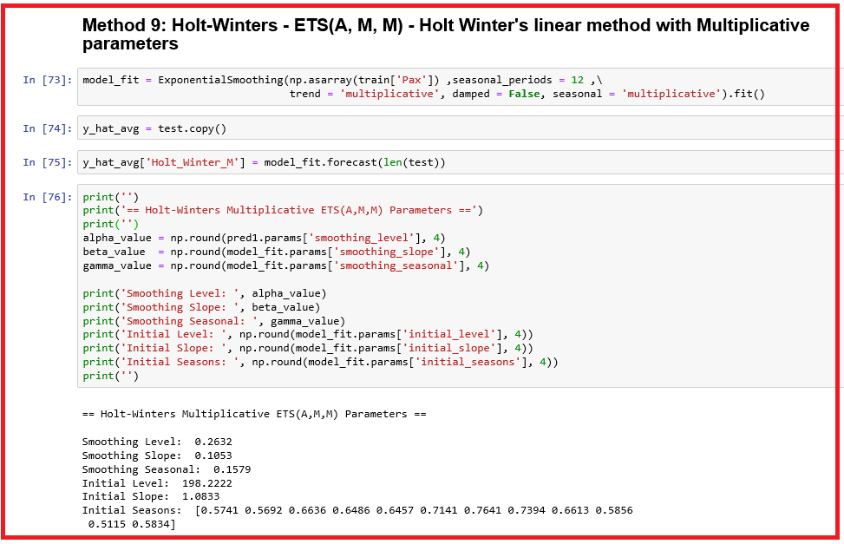

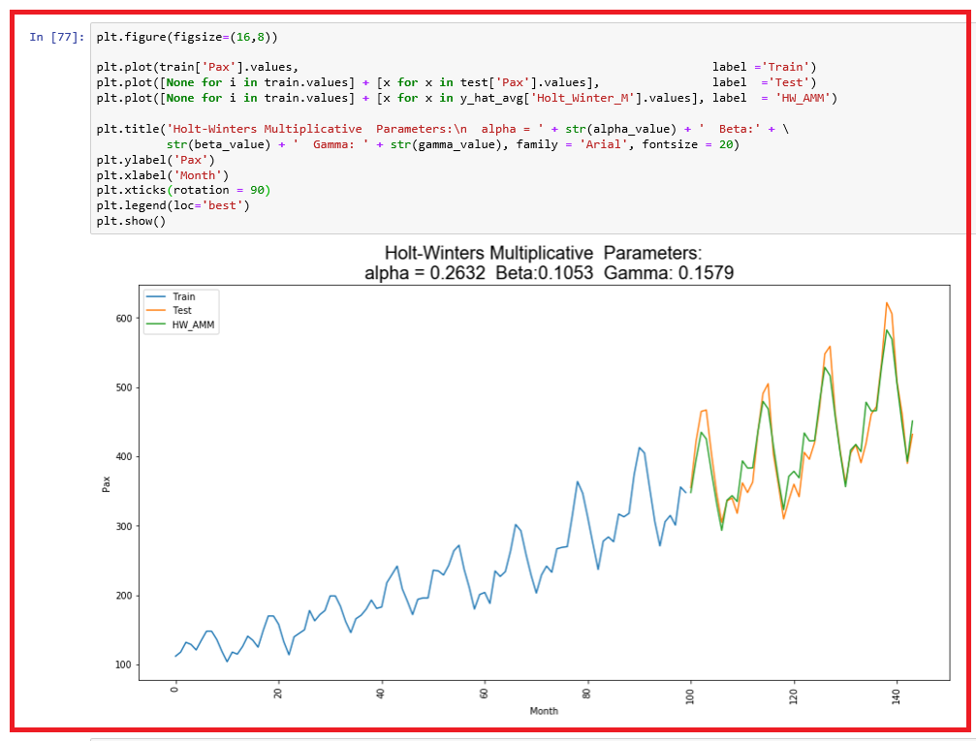

* *We observe that there is a little gap between the actual and forecasted values. We shall compute RMSE and MAPE now.*

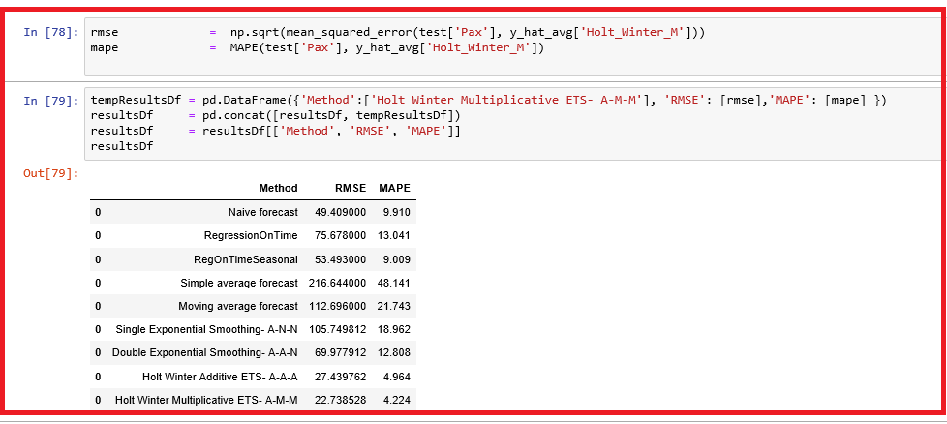

* *We observe that HW – AMM model better than other models we have tried so far*

## AUTO-REGRESSIVE MODELS

* *Auto-regressive (AR) and moving average (MA) models are popular models that are frequently used for forecasting.*
* *AR and MA models are combined to create models such as auto-regressive moving average (ARMA) and auto-regressive integrated moving average (ARIMA) models.*
* *The initial ARMA and ARIMA models were developed by Box and Jenkins in 1970.*
* *ARMA models are basically regression models; auto-regression means regression of a variable on itself measured at different time periods.*
* *The main assumption of AR model is that the time series data is stationary.*
* *A stationary time series is one whose statistical properties such as mean, variance, autocorrelation, etc. are all constant over time.*

*http://people.duke.edu/~rnau/411diff.htm*

* *When the time series data is not stationary, then we convert the non-stationary data before applying AR models.*

**Lags**

* *Taking the difference between consecutive observations is called a lag-1 difference.*
* *For time series with a seasonal component, the lag may be expected to be the period (width) of the seasonality.*
* *White noise of the residuals:*
* *White noise is a process of residuals ϵt that are uncorrelated and follow normal distribution with mean 0 and constant standard deviation. In AR models, one of the main assumptions is the errors follow a white noise.*

**Auto-Regressive (AR) Models**

* *Auto-Regression is a regression of a variable on itself measured at different time points. Auto-Regressive model with lag 1, AR(1) is given by*

*Yt+1 = 𝛽 Yt + ϵt+1*

* *and this same as Yt+1 – μ = 𝛽 (Yt − μ) + ϵt+1 where*
* *ϵt+1* is a sequence of uncorrelated residuals that follow normal distribution with zero mean and constant deviation.
* Yt+1 − μ is interpreted as a deviation from mean value μ and known as mean cantered series.
* *The Augmented Dickey Fuller Test (ADF) is unit root test for stationarity. The null hypothesis is that time series is non-stationary. Alternative hypothesis is that time series is stationary.*

**AR Model identification**

**Auto-Correlation Function (ACF) or correlogram and Partial Auto-Correlation Function (PACF)**

**Autocorrelation Function (ACF)**

* *A plot of auto-correlation of different lags is called ACF.*
* *The plot summarizes the correlation of an observation with lag values. The x-axis shows the lag and the y-axis shows the correlation coeﬃcient between -1 and 1 for negative and positive correlation.*

**Partial Autocorrelation Function (PACF)**

* *A plot of partial auto-correlation for different values of lags is called PACF.*
* *The plot summarizes the correlations for an observation with lag values that is not accounted for by prior lagged observations.*
* *Both plots are drawn as bar charts showing the 95% and 99% conﬁdence intervals as horizontal lines. Bars that cross these conﬁdence intervals are therefore more signiﬁcant and worth noting. Some useful patterns you may observe on these plots are:*
* *The number of lags is p when:*
* *The partial auto-correlation, |ρpk | > 1.96 / √n for first p values and cuts off to zero.*
* *The auto-correlation function, ρk decreases exponentially.*
* *The model is AR if the ACF trails oﬀ after a lag and has a hard cut-oﬀ in the PACF after a lag. This lag is taken as the value for p.*
* *The model is MA if the PACF trails oﬀ after a lag and has a hard cut-oﬀ in the ACF after the lag. This lag value is taken as the value for q.*
* *The model is a mix of AR and MA if both the ACF and PACF trail oﬀ.*
* *For an ARIMA (p, d, q) process, it becomes non-stationary to stationary after differencing it for d times.*

### ARIMA model

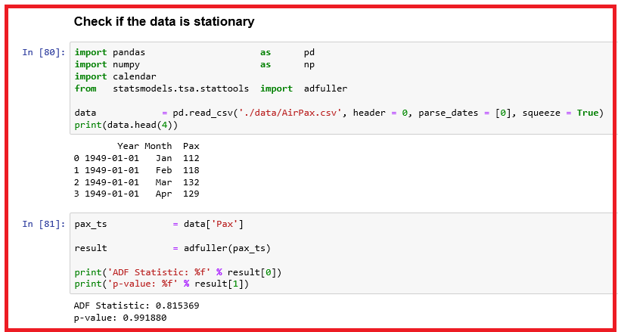

* *Since the series is not stationary, try differencing till the series becomes stationary.*

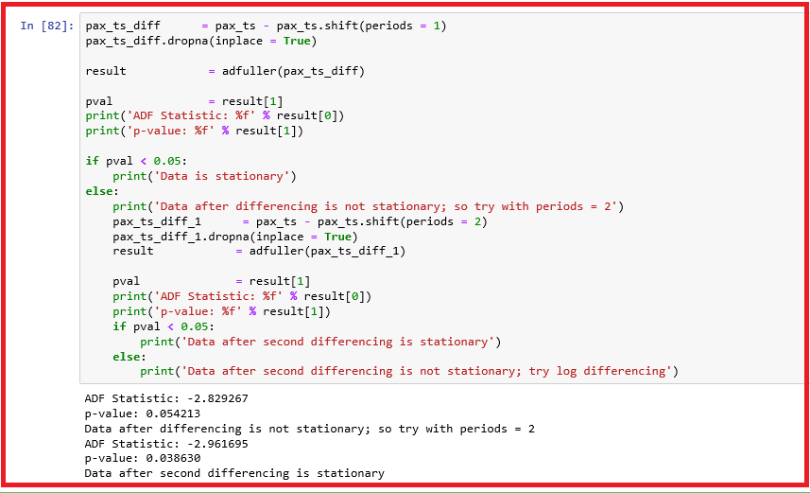

* The series has become stationary after differencing twice.
* Now, we know the value of d, parameter is 2. Let us find out the values for parameters, p and q using ACF and PACF plots.

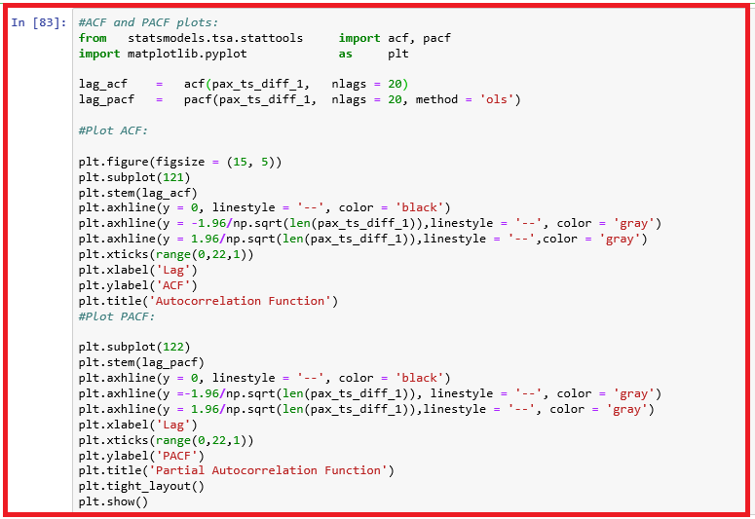

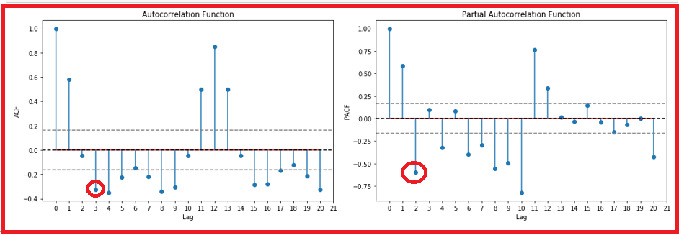

* From the above ACF and PACF plots, we observe that the value of p = 3 and q = 2. Since we have the required parameter values for ARIMA model, we can build the ARIMA (3, 2, 2) model.

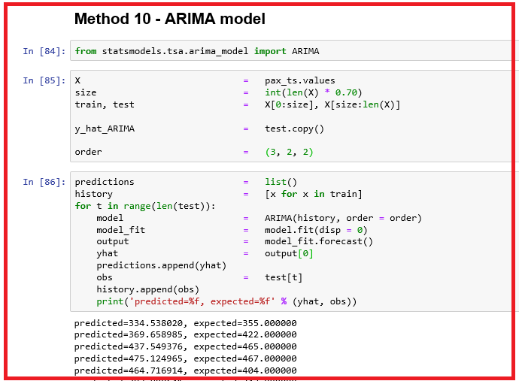

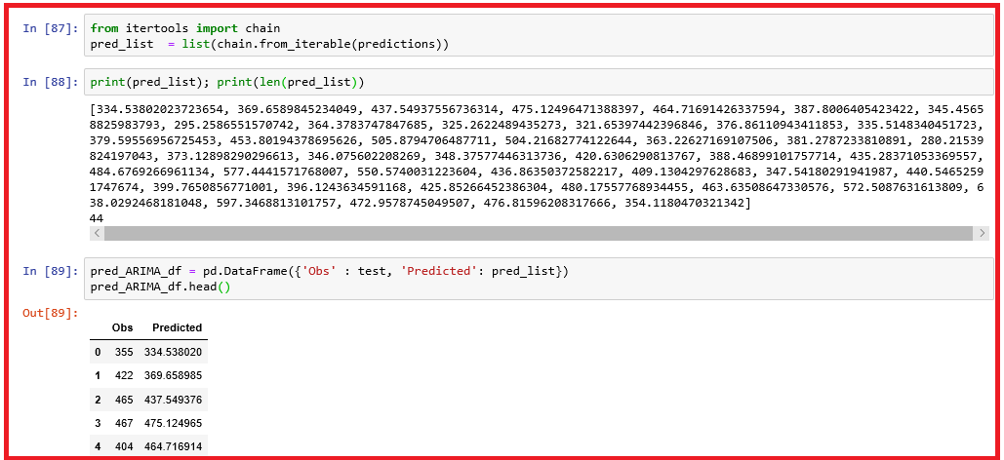

* Examine visually the deviation between observed and predicted values.

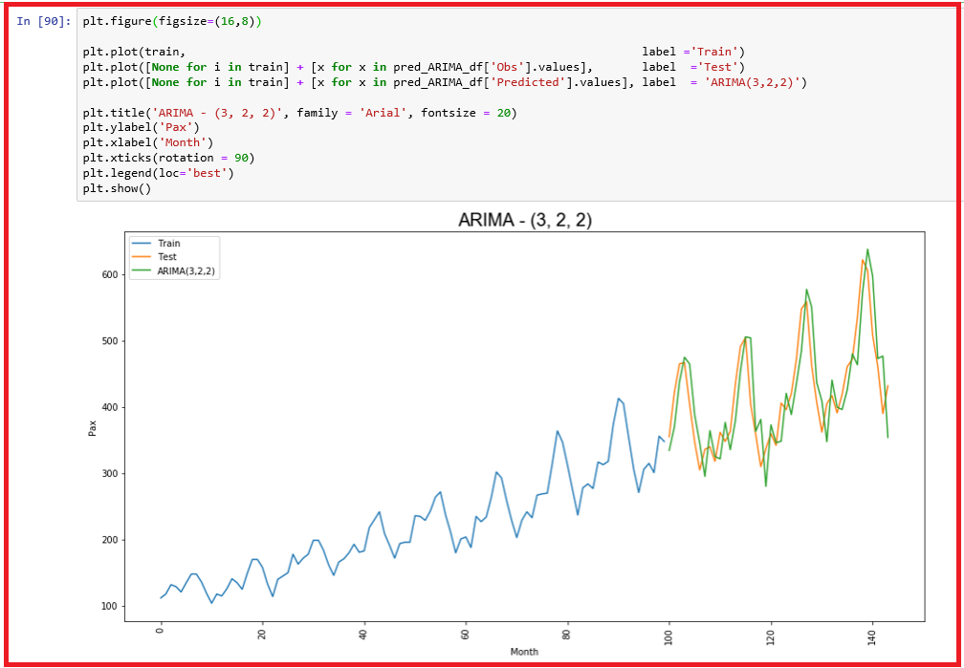

* *We observe that there is a little gap between the actual and forecasted values. We shall compute RMSE and MAPE now.*

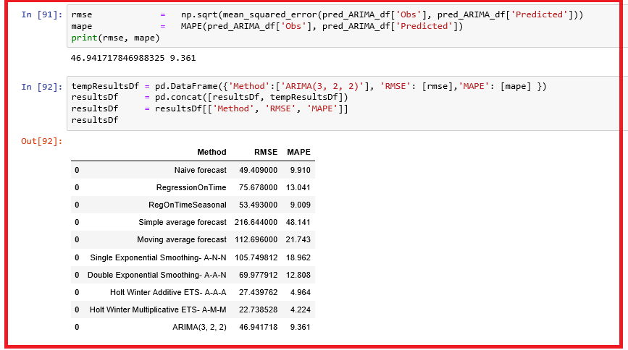

* *We observe that our ARIMA model performs worse than Holt-Winter models. When trend and seasonality is present in a time series, a very popular method is to use the seasonal autoregressive integrated moving average (SARIMA) model. Let us try SARIMA model.*

### SARIMA model

* *This is a generalization of an ARMA model. SARIMA models are denoted SARIMA(p, d, q) (P, Q, D)[S], where S refers to the number of periods in each season, d is the degree of differencing, P, D and Q refer to the autoregressive, differencing, and moving average terms for the seasonal part of the ARIMA model.*
* *SARIMA(1, 1, 1) (1, 1, 1) [7] is written as:*

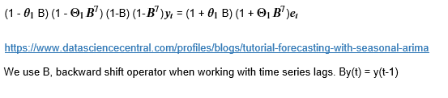

**Identify d, the order of differencing**

* When d = 0, ACF at all lags is low or the series has no visible trend
* When d >= 1, ACF values are positive (large values) or series has visible trend
* When d = 1, then the original series has a constant trend,
* When d = 2, it is an indication of time varying trend in the original series.
* When ACF at lag 1 is -0.5 or less, the series is over-differenced

**Identify the number of AR (p) terms and MA (q) terms**

* p = first lag where the PACF value is above the significance level
* q = first lag where the ACF value is above the significance level

**Identify the seasonal part of the model**

* S = ACF lag with the highest value
* If the series has a stable seasonal pattern over time, D = 1
* If the series has an unstable seasonal pattern over time, D = 0
* Thumb Rule: d + D ≤ 2
* If ACF is positive at lag S, P ≥ 1 else P = 0
* If ACF is negative at lag S, Q ≥ 1 else Q = 0
* Thumb rule: P + Q ≤ 2
* We apply parsimony principle to prevent overfitting problem through a constraint, p + q + d + P + D + Q ≤ 6.
* It is best to manually experiment with different parameters using ACF / PACF plots.

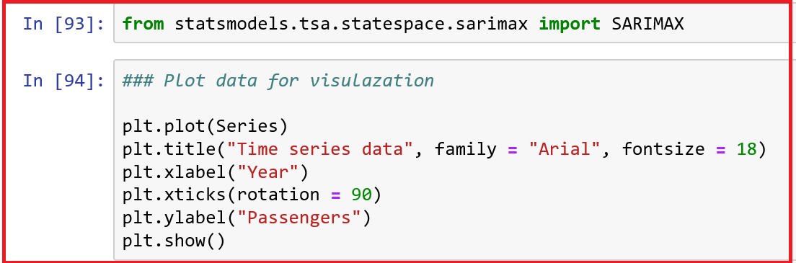

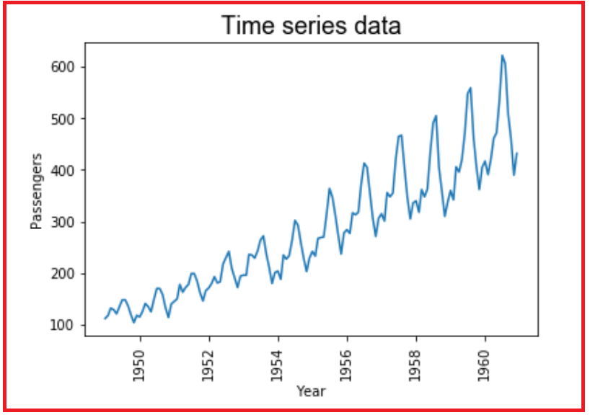

* When we observe the time-series has a positive linear trend, multiplicative seasonal patterns, and possibly some irregular patterns. This information forces us to use SARIMA model to do our forecasting.
* We apply a log filter since the data has multiplicative seasonality to analyse the residuals with autocorrelation plots.

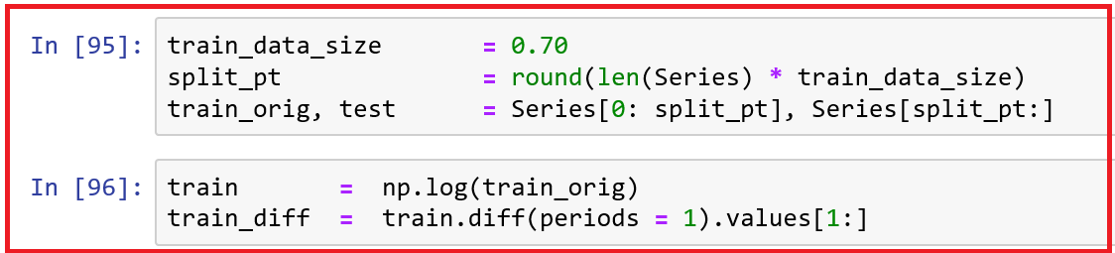

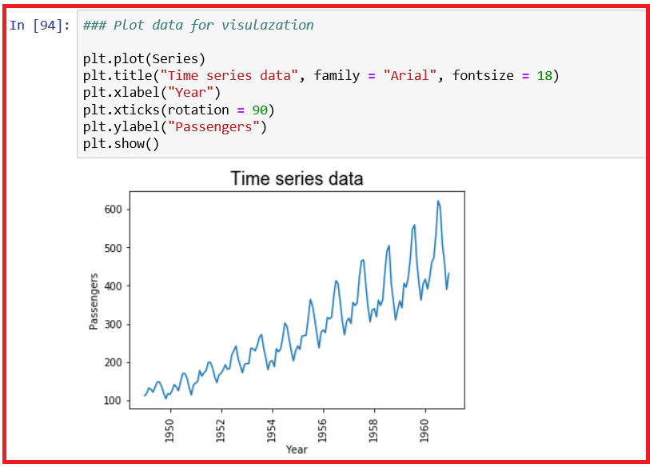

* Now we observe that there is no more a multiplicative affect and no more trend. An unstable seasonal pattern is still present in this residual series.
* So, we need to remove the seasonal pattern using SARIMA.
* Select the seasonal pattern parameters of SARIMA by looking at the ACF and PACF plots.

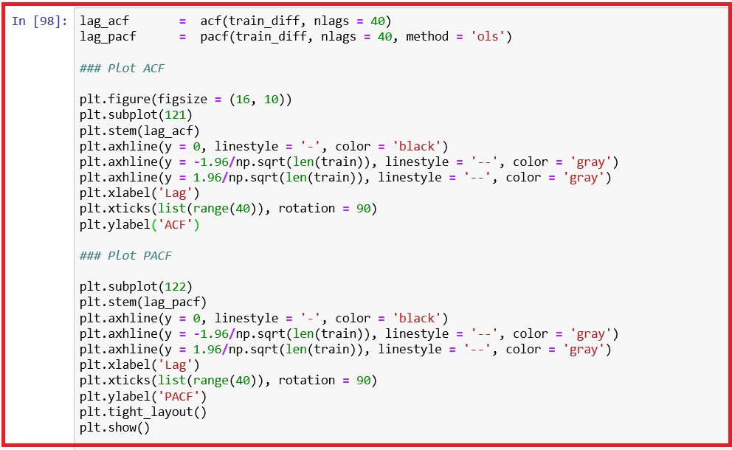

**ACF and PACF plots**

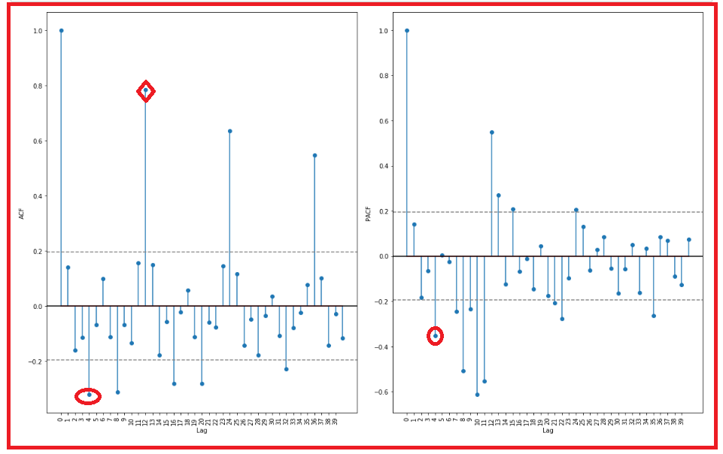

* By observing the ACF and PACF plots of the differenced series, the significant value at lag 4 for ACF and at the same time lag 4 for the PACF. So, we use p = 4, q = 4
* At lag = 12, we observe a big positive value in the ACF plot, suggesting that our season, S = 12 and P = 1 , Q = 0
* We set d = 1 because of the differenced series. We set D = 0 when the seasonal pattern is not stable.
* So, we now have SARIMA(4,1,4)(1,0,0)[12] model.
* We shall use input data, train and state the d parameter value is 1. If you use train_diff, you need to set the value of the parameter, d to 0.
* The parameters, enforce_stationarity and enforce_invertibility refer to the options to transform AR and MA parameters to enforce stationarity in the respective components.
* The parameter, disp = False suppresses printing of convergence messages.

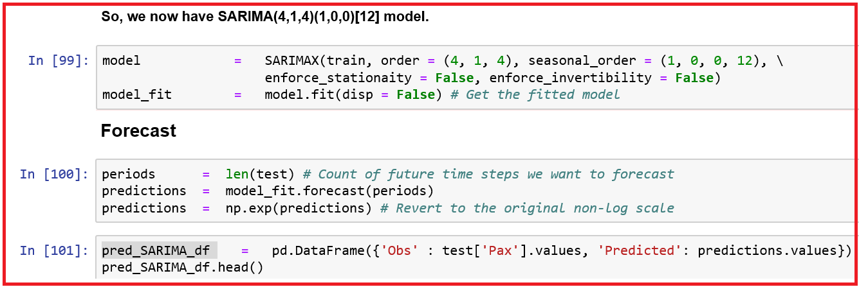

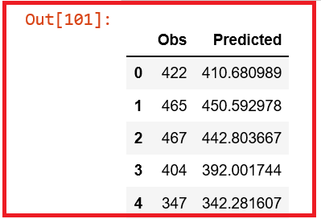

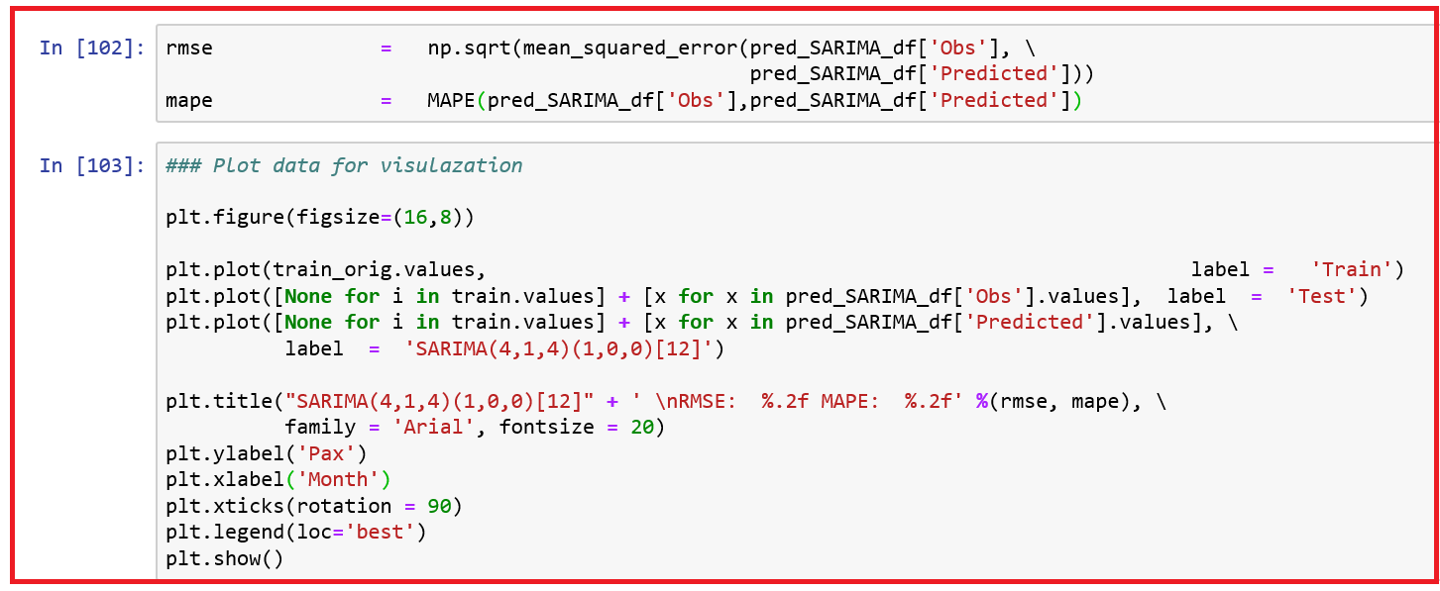

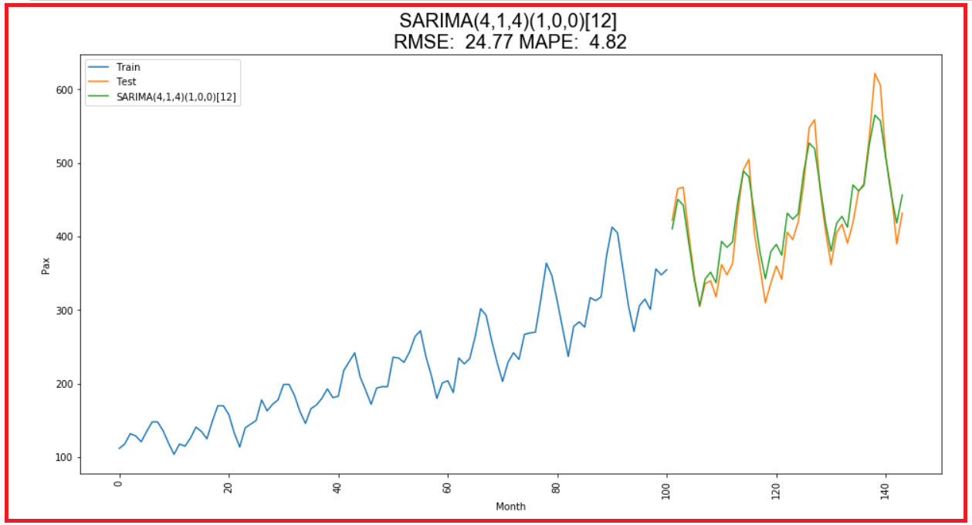

* *We observe that there is a little gap between the actual and forecasted values. We shall compare the RMSE and MAPE of this model with other models.*

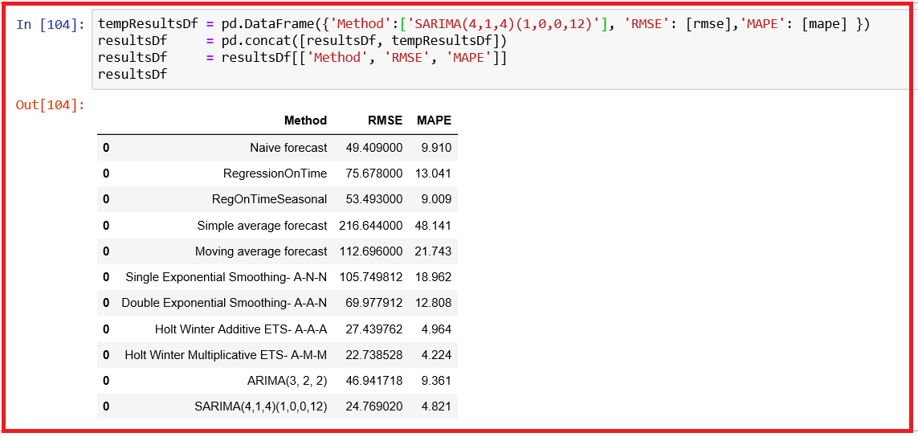

* *We observe that the SARIMA model performs better than all the other models except Holt-Winter Multiplicative ETS – A-M-M model.*